**Task on Load balancers**

**Introduction to Load Balancers**

A **Load Balancer** is a networking service that distributes incoming traffic across multiple backend servers to ensure high availability, reliability, and scalability. It helps prevent server overload, improves application performance, and enhances fault tolerance.

**Types of Load Balancers**

1. **Application Load Balancer (ALB)** – Operates at the **application layer (Layer 7)** of the OSI model, intelligently routing requests based on content, headers, and paths.
2. **Network Load Balancer (NLB)** – Works at **Layer 4**, efficiently handling high-throughput traffic with ultra-low latency.
3. **Classic Load Balancer (CLB)** – Legacy option that supports basic load balancing for EC2 instances.
4. **Gateway Load Balancer (GLB)** – Designed for **third-party virtual appliances**, enabling seamless traffic inspection.

**Key Features**

* **Traffic Distribution** – Balances requests across multiple targets (EC2 instances, containers, IP addresses).
* **Health Checks** – Monitors backend servers and routes traffic only to healthy instances.
* **Auto Scaling Integration** – Works with AWS Auto Scaling to dynamically adjust resources.
* **SSL Termination** – Offloads SSL/TLS encryption to improve backend performance.
* **Sticky Sessions** – Maintains session persistence for applications requiring consistent user connections.

**Use Cases**

* **Web Applications** – Distributes traffic across multiple web servers for high availability.
* **Microservices** – Routes requests based on URL paths to different services.
* **Gaming & Streaming** – Ensures low-latency connections for real-time applications.

1) Configure Classic Load balancer

Create a Classic Load Balancer

- Open the AWS EC2 console.

- Navigate to Load Balancers → Click Create Load Balancer.

- Select Classic Load Balancer → Click Create.

- Enter a name for the load balancer.

- Choose Internet-facing or Internal based on your needs.

Configure Listeners

- Select the protocol and port for front-end connections (e.g., HTTP:80 or HTTPS:443).

- Choose the protocol and port for back-end connections (e.g., HTTP:80).

- If using HTTPS, select an SSL certificate from AWS Certificate Manager (ACM).

Configure Health Checks

- Set the Ping Protocol (HTTP or TCP).

- Define the Ping Path (e.g., /health for web applications).

- Set Healthy Threshold, Interval, Timeout, and Unhealthy Threshold.

Register EC2 Instances

- Select the EC2 instances to associate with the load balancer.

- Click Add to Load Balancer.

- Ensure instances are in the same VPC as the load balancer.

Configure Security Groups

- Allow inbound traffic on port 80 (HTTP) and port 443 (HTTPS).

- Ensure the security group allows traffic from the load balancer.

Enable Access Logging (Optional)

- Go to Attributes → Enable Access Logs.

- Specify an S3 bucket for log storage.

Verify and Test

- Open a browser and enter the Load Balancer DNS name.

- Ensure traffic is correctly routed to backend instances.

- Check CloudWatch metrics for performance monitoring.

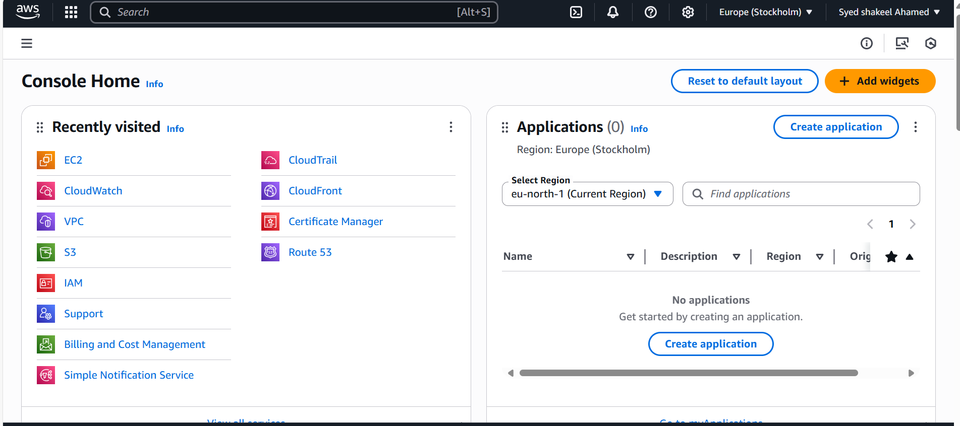

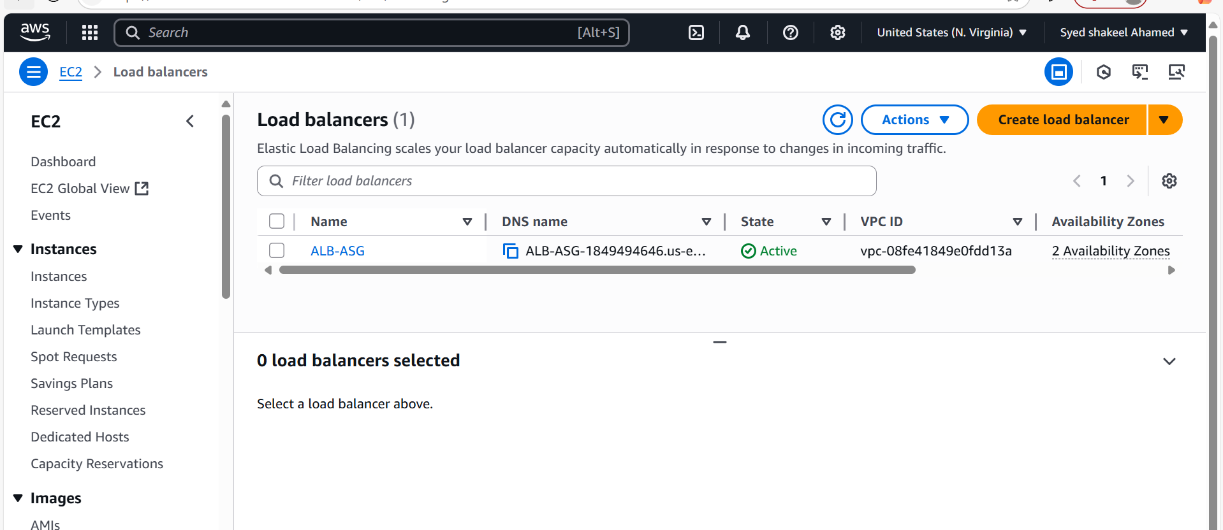

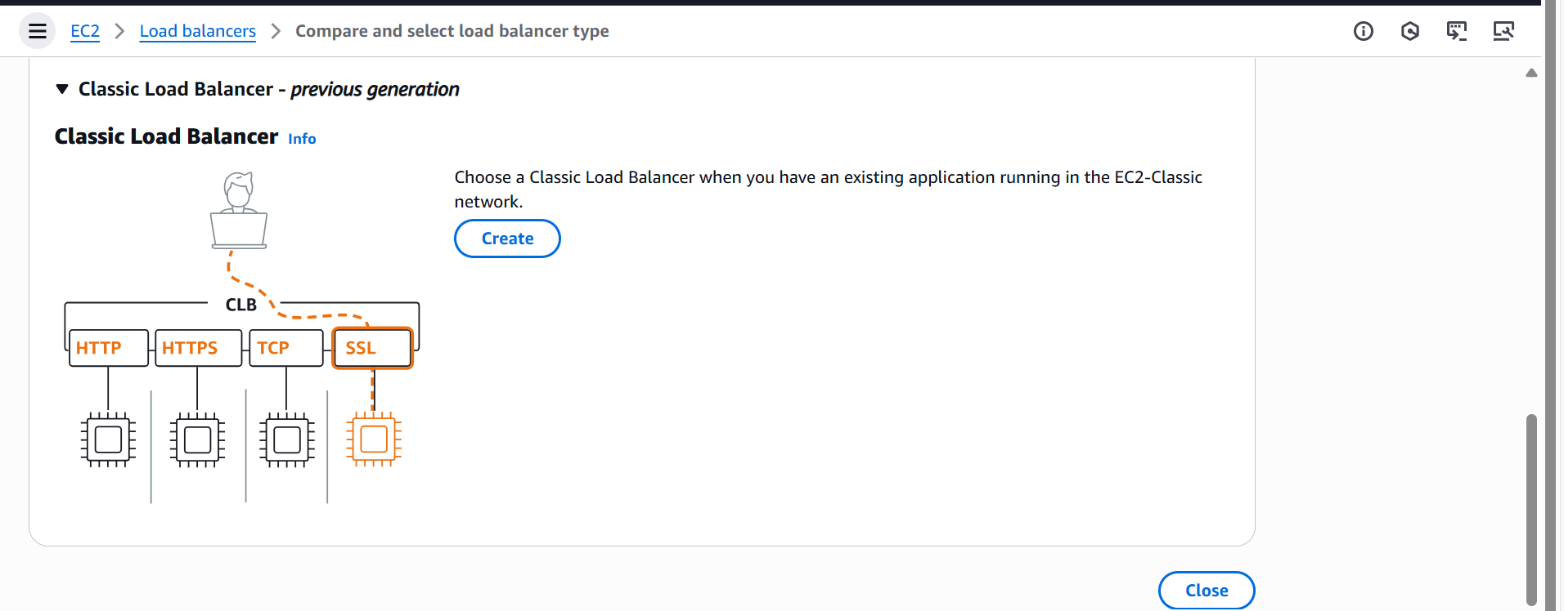

**How Classic Load Balancers work**

1. Clients make requests to your application.
2. The listeners in your load balancer receive requests matching their protocol and port.
3. The receiving listener forwards requests to healthy registered instances using the routing algorithm of the listener protocol. You configure the health checks that monitor the health of the registered instances.
4. The healthy instances receive traffic. You can register or deregister instances to your load balancer either manually or by way of an autoscaling group without disrupting the overall flow of requests to your application.

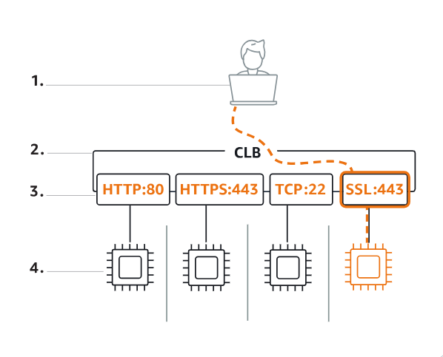

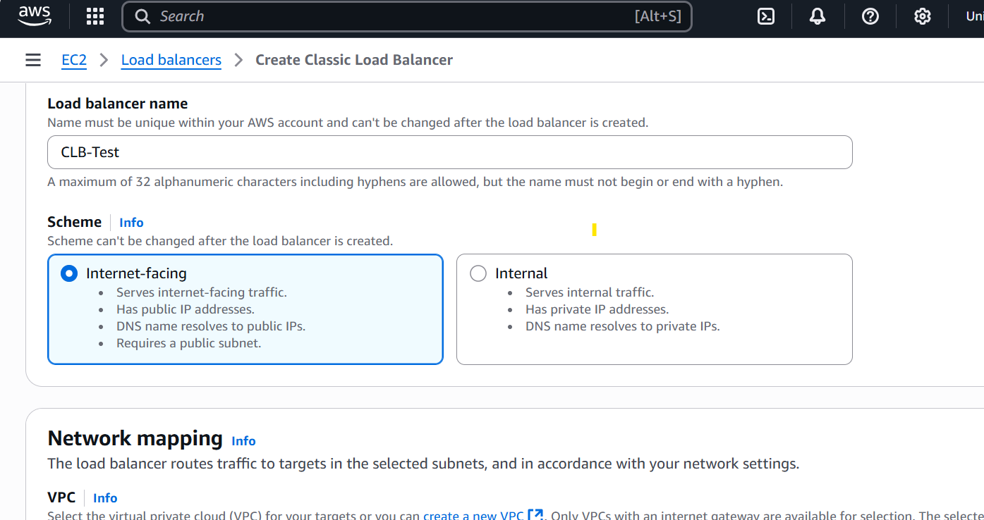

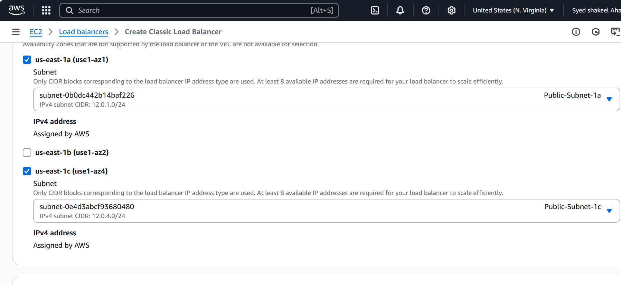

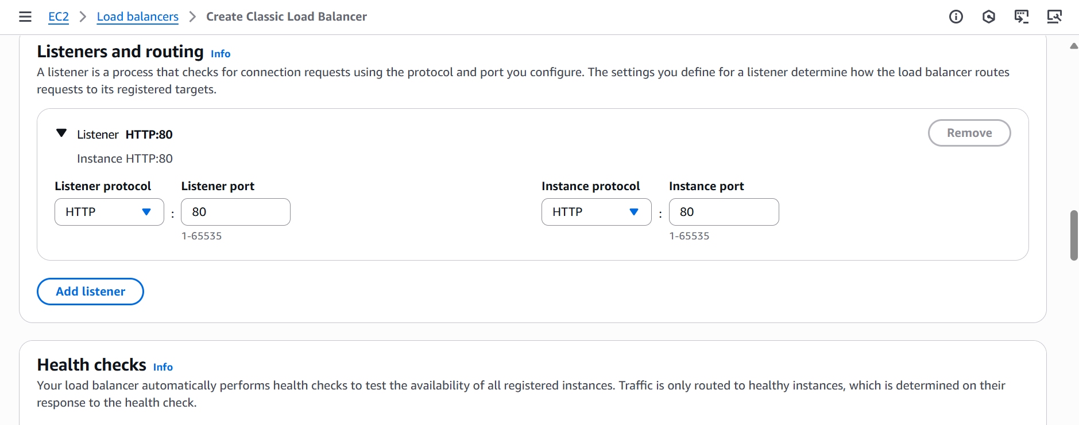

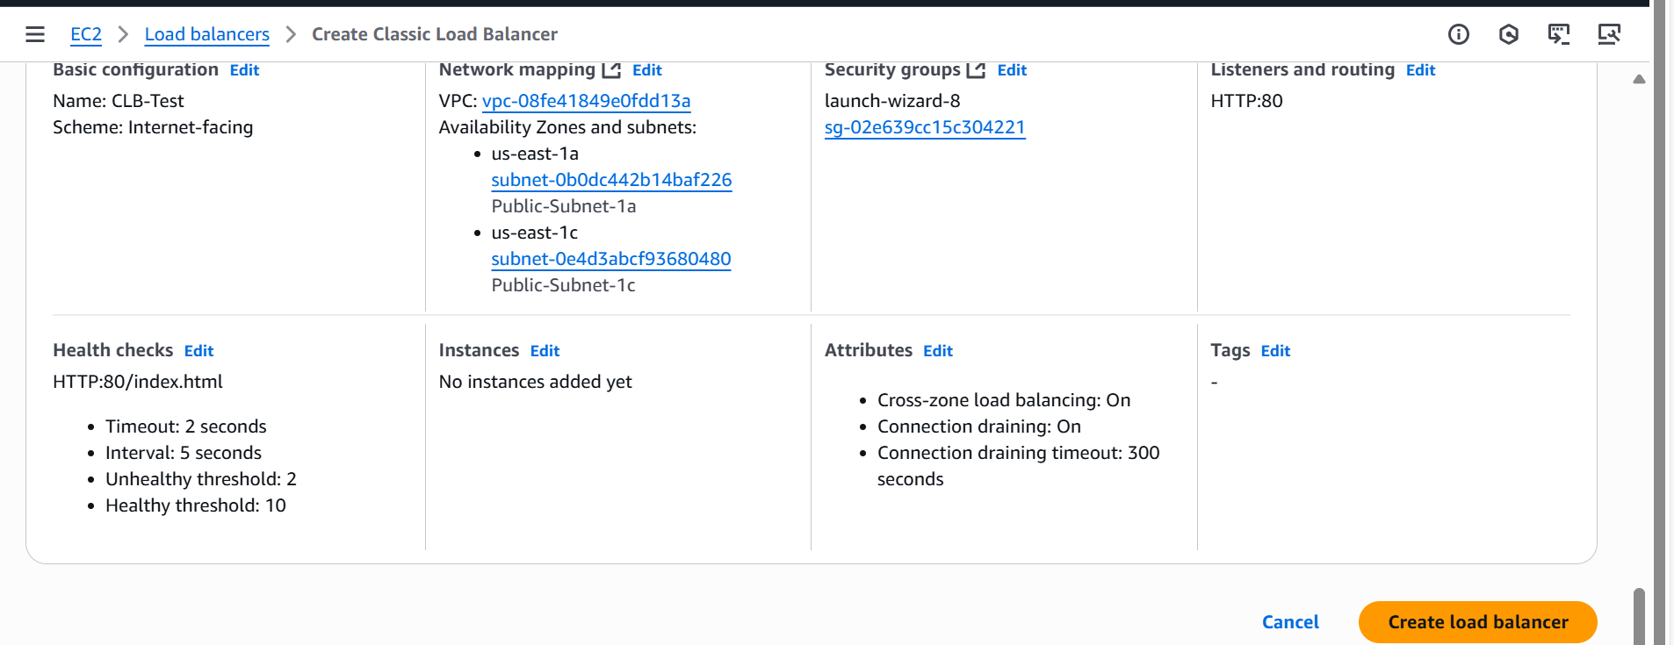

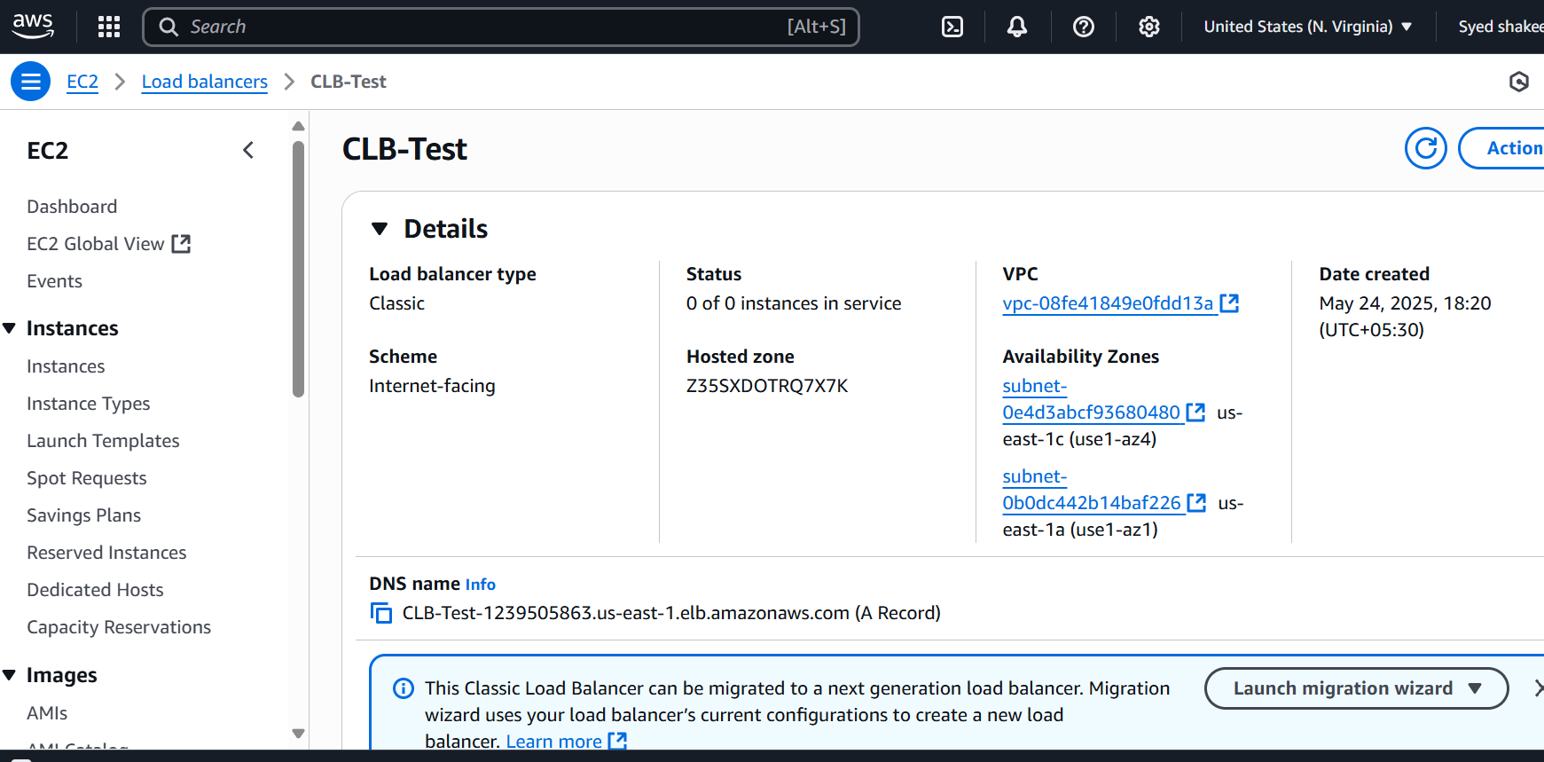

Launch EC2 instance –Server1

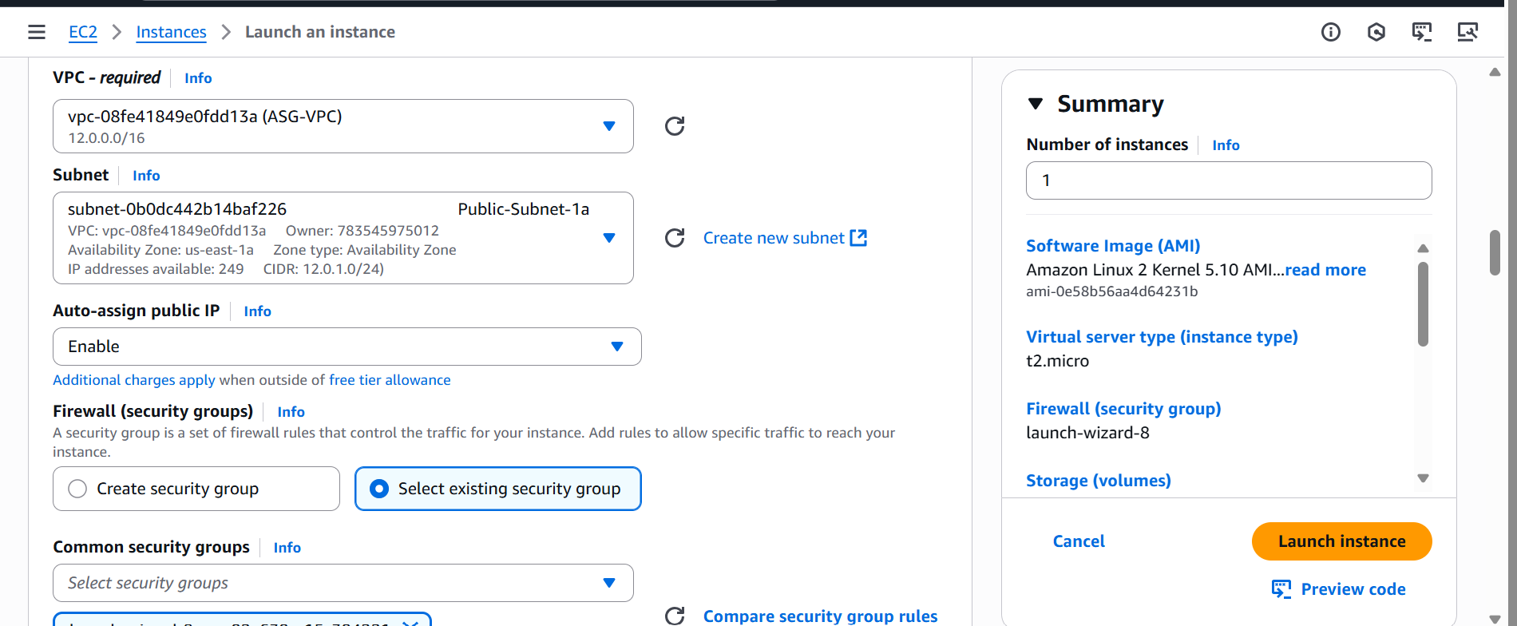

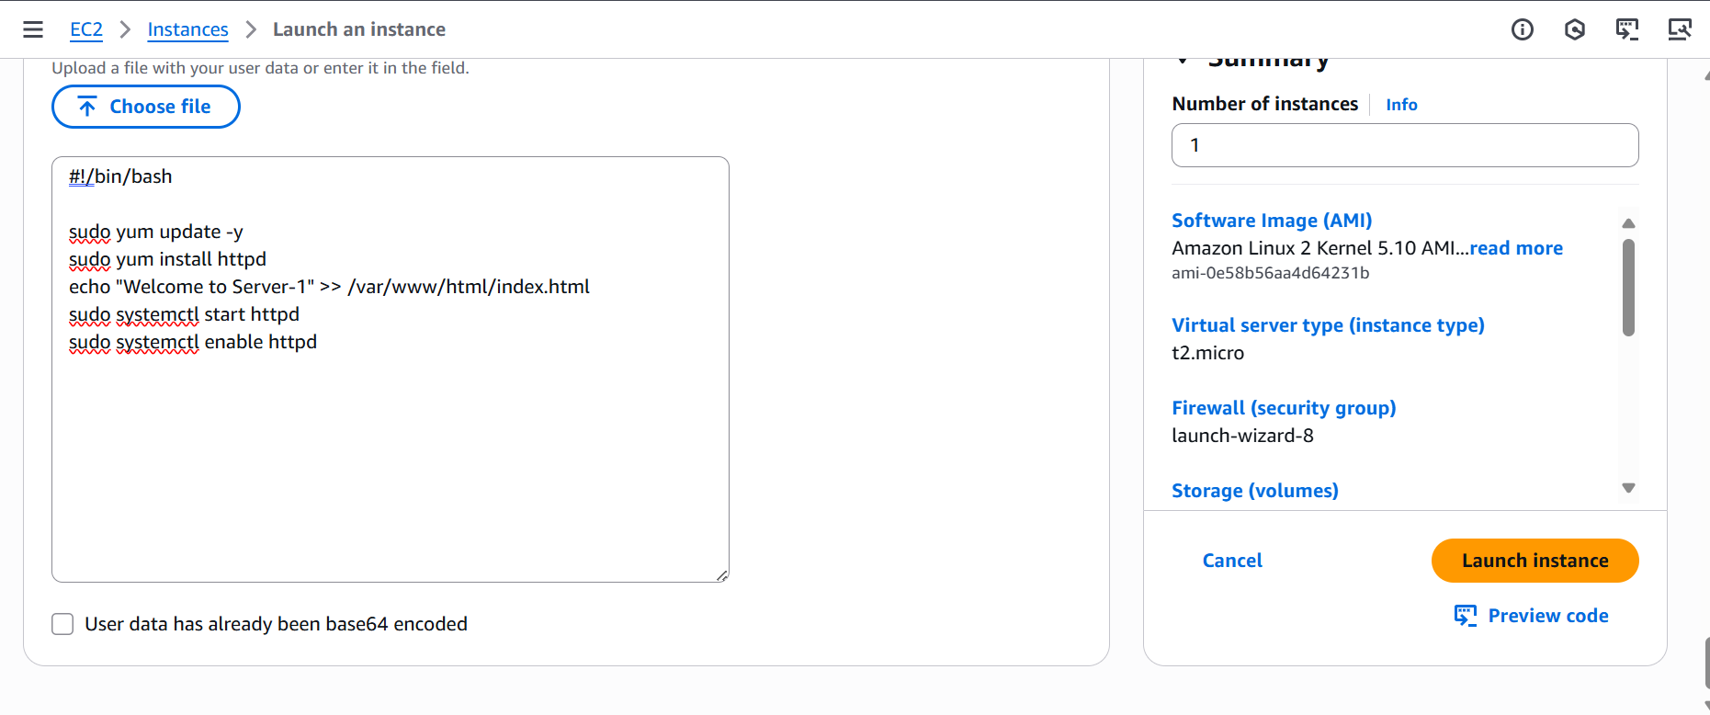

Launch Another EC2- server-2

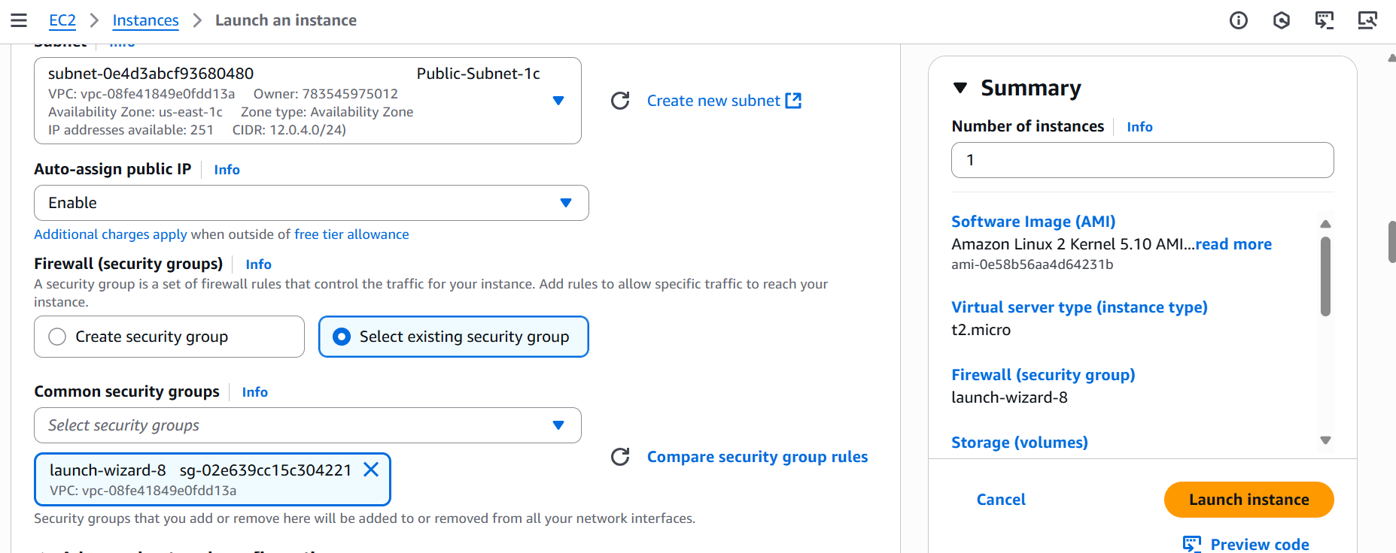

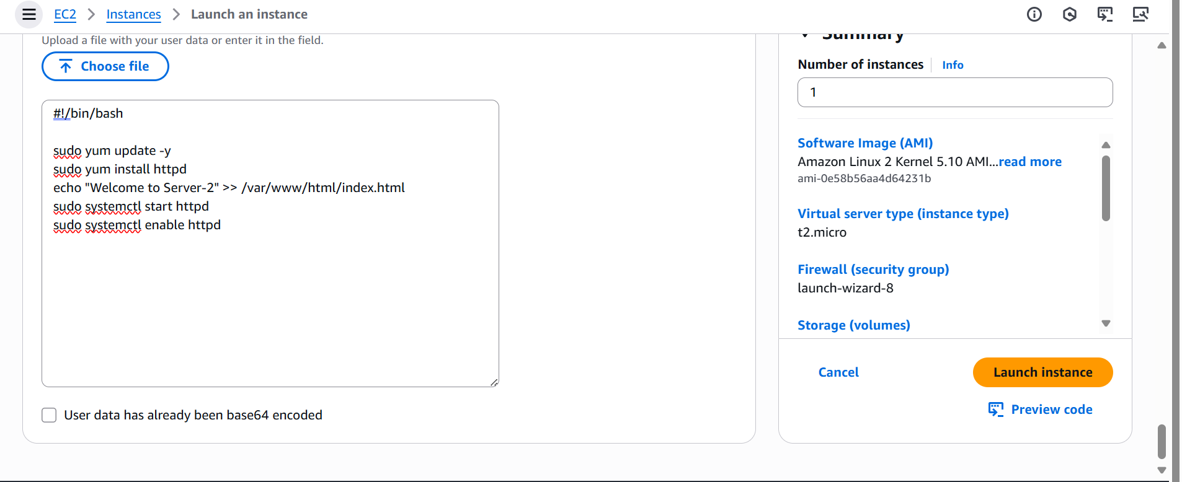

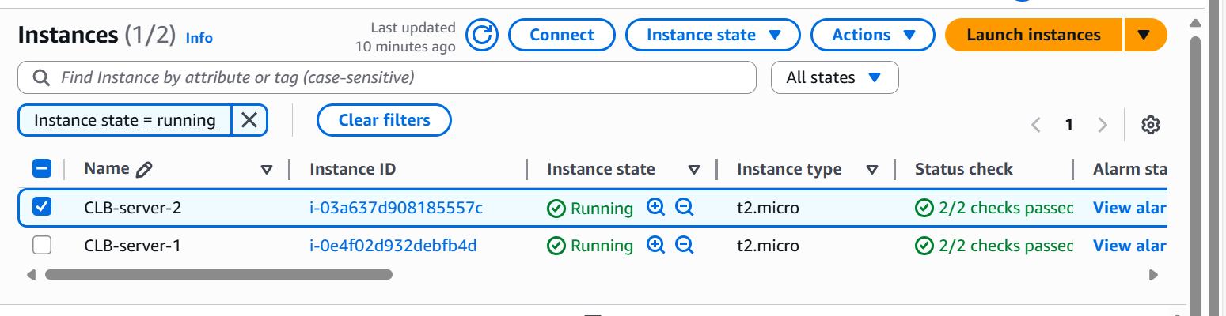

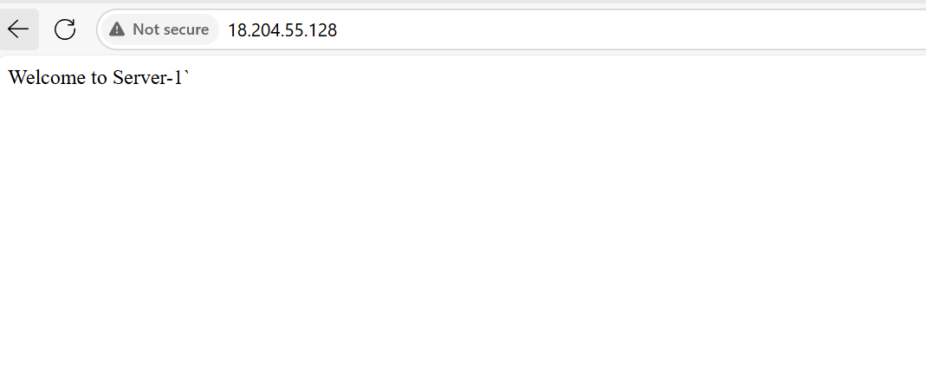

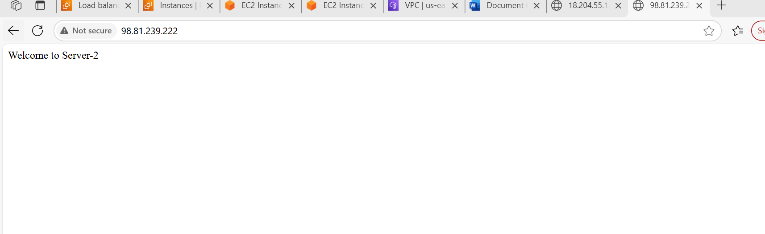

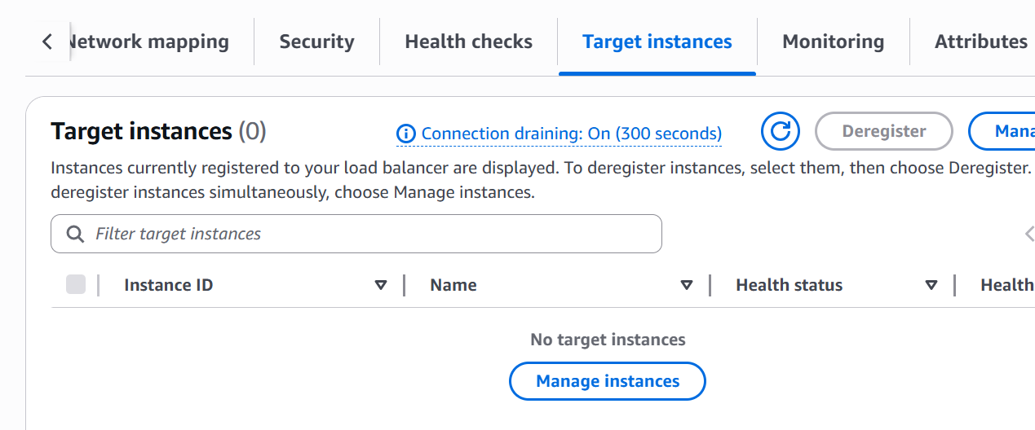

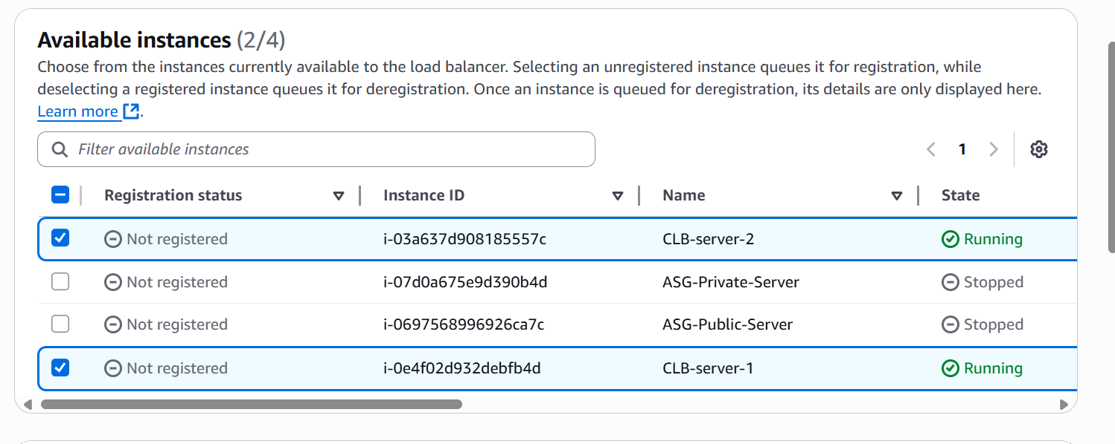

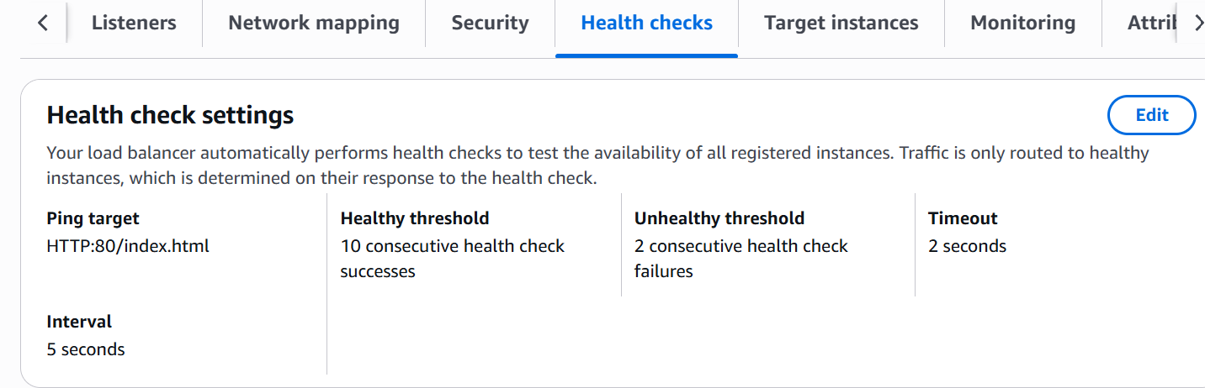

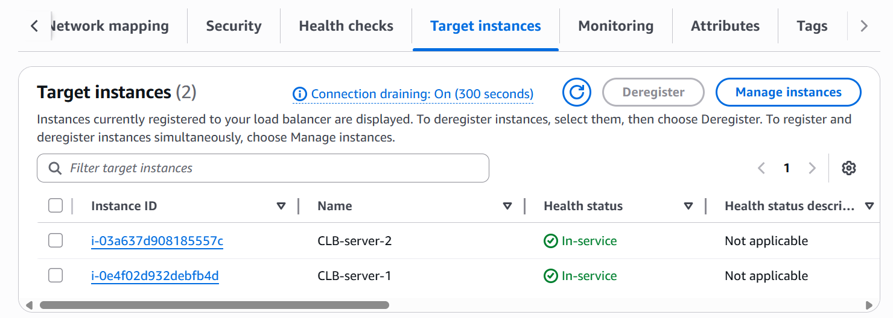

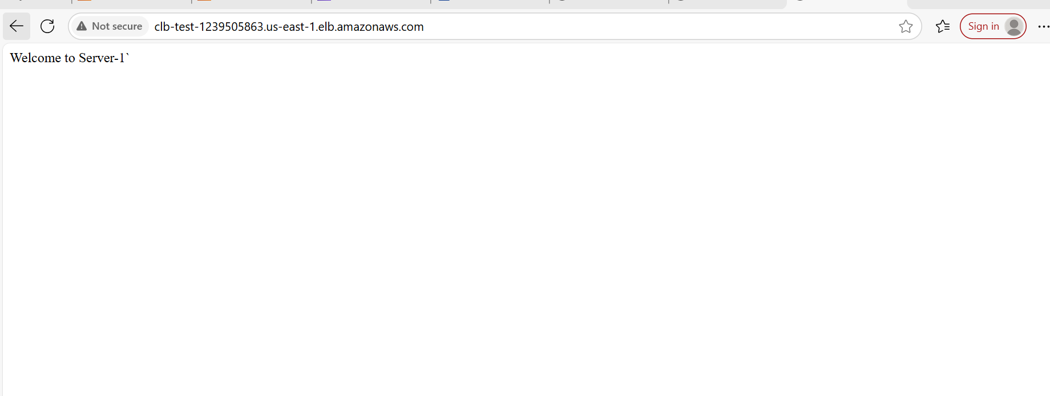

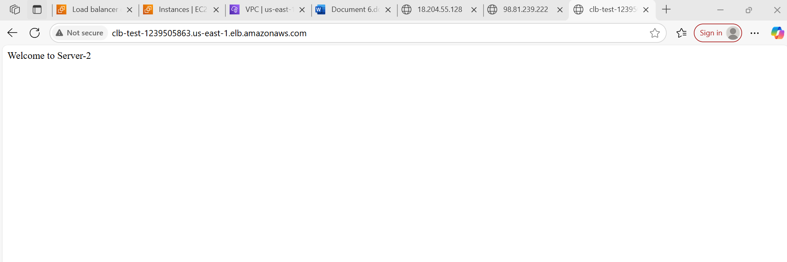

2) Configure Application Load balancer

Go to Amazon console and select Load balancer service

Click on Create Load balancer

Select Application Load balancer and click on create

Enter Load balancer name as ALB-ASG

Scheme internet facing

Ip address type as IPv4

Select VPC which created and select atleast 2 availabilty zones and their subnets

Come to Listeners and rules

Select the Listener protocol HTTP and port 80

Now it will ask to select the Default action to select the Traget group

Create once Target Group

Provide Target group name and select the required detailes as VPC and remaining

Now come to Register Targets select the available instances of Public and Private servers

Once successfully created the target group

Now come Load balancer page select the target group created

Check the summary and click on create Load Balancer

Once the Load balancer provisioned successfully need to add rule in Actions

Once it is configured successfully check the health status of the Instances.

Try access with DNS of Load balancer , Now you will be successfully seen the sample index.html page which we deployed in Public and Private servers

This way we have successfully attached the instances to Load balancer

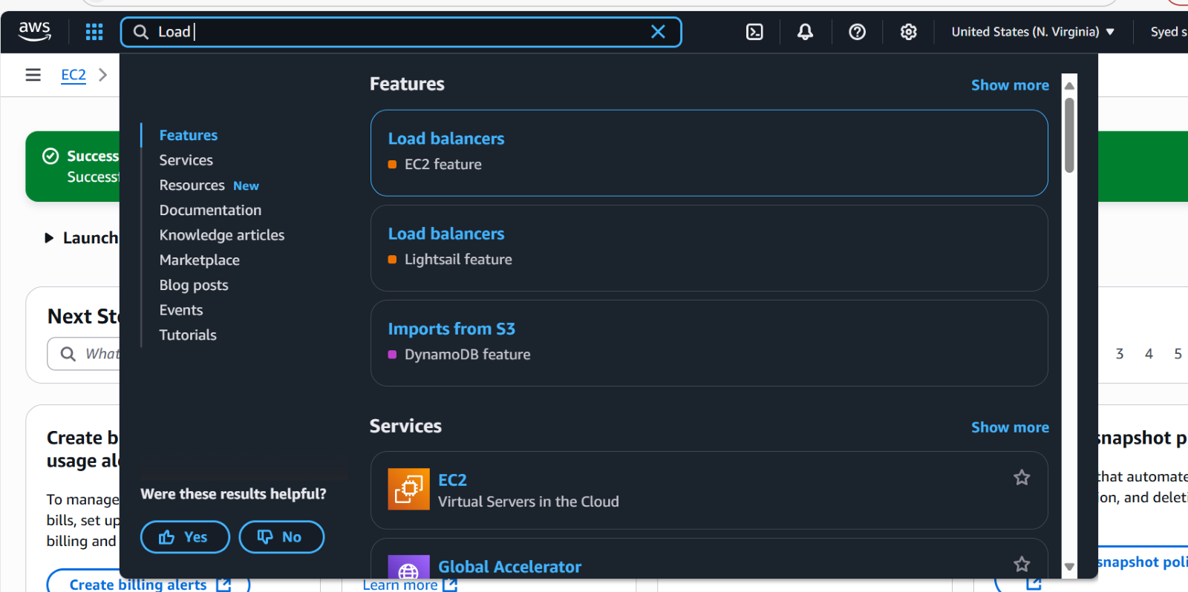

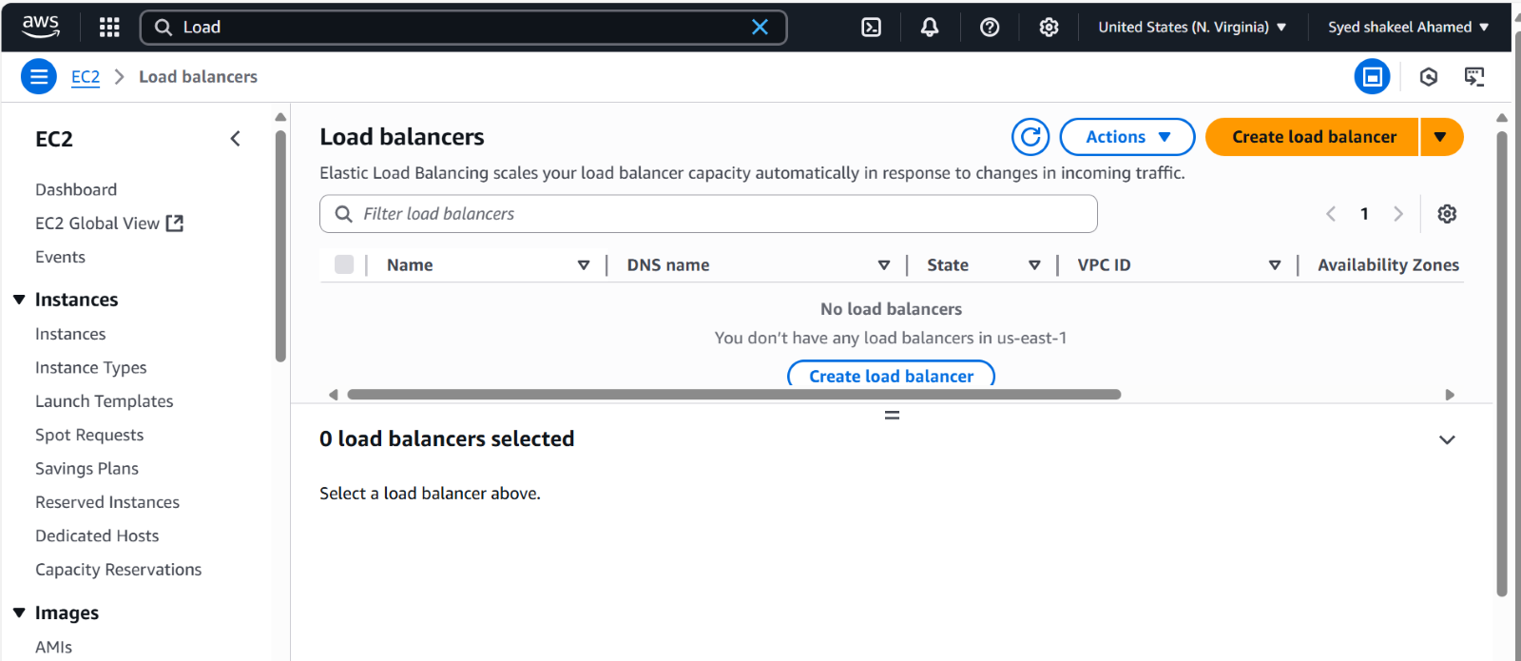

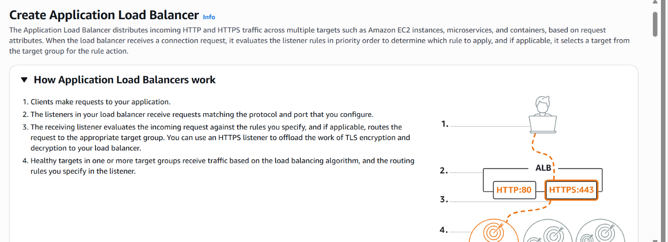

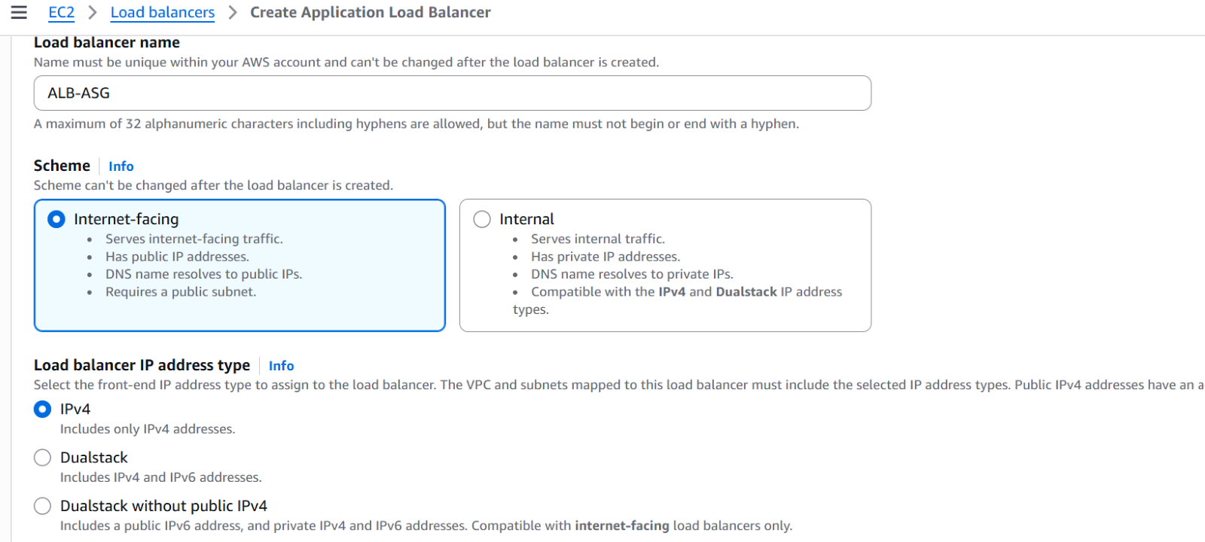

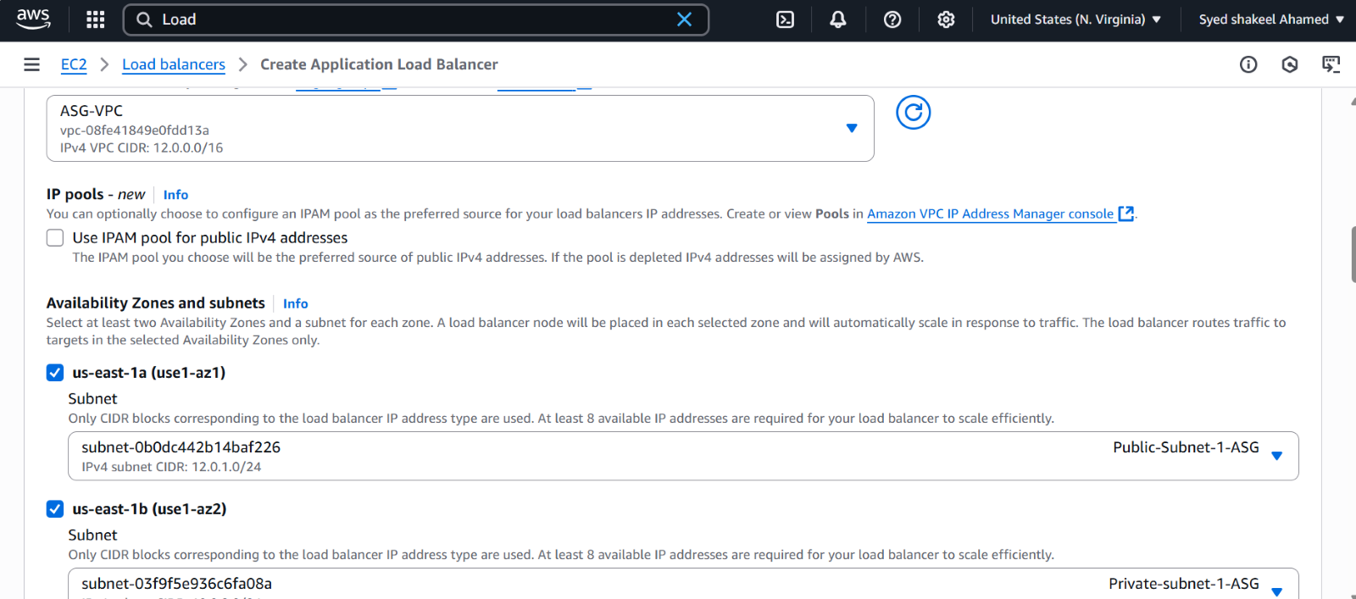

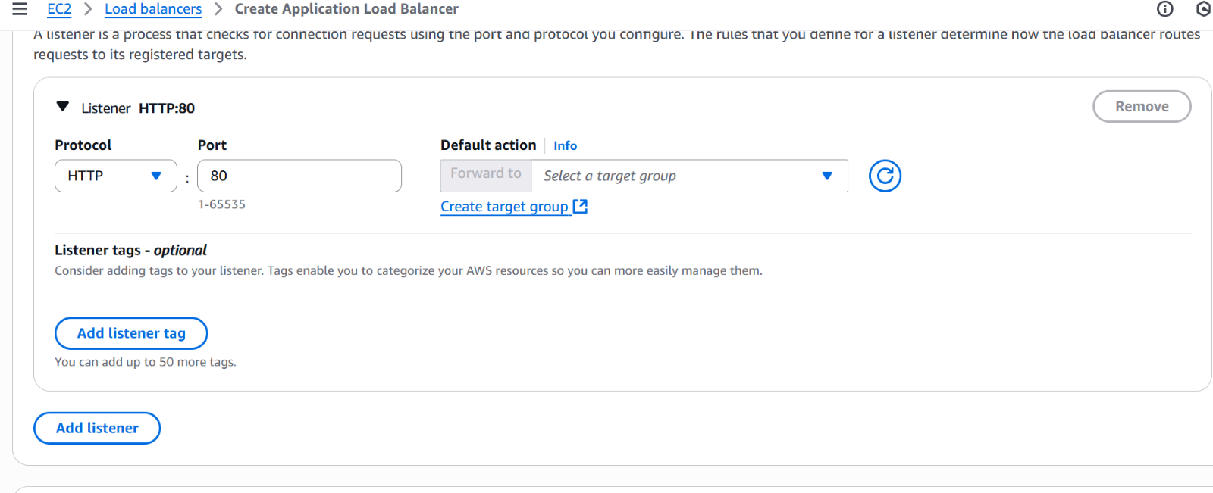

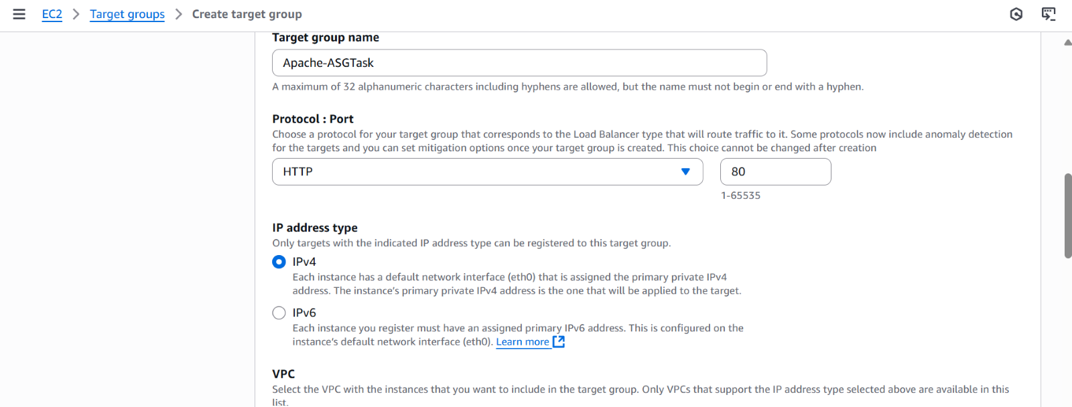

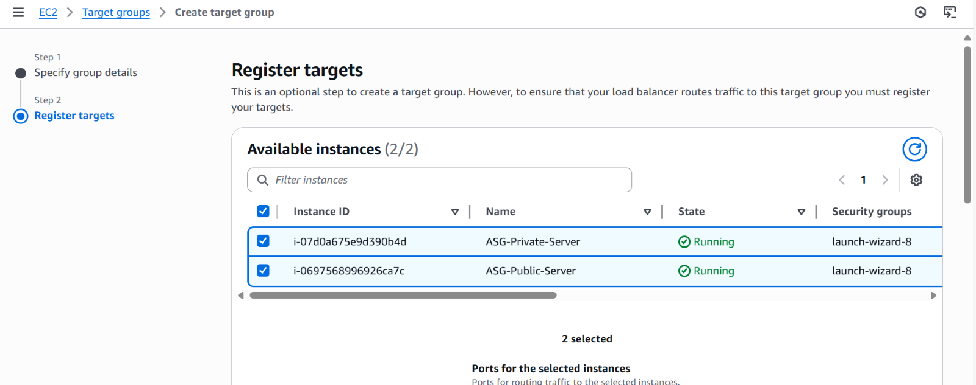

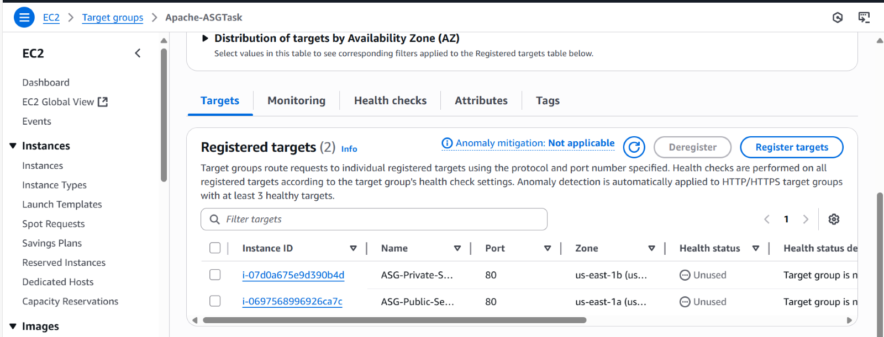

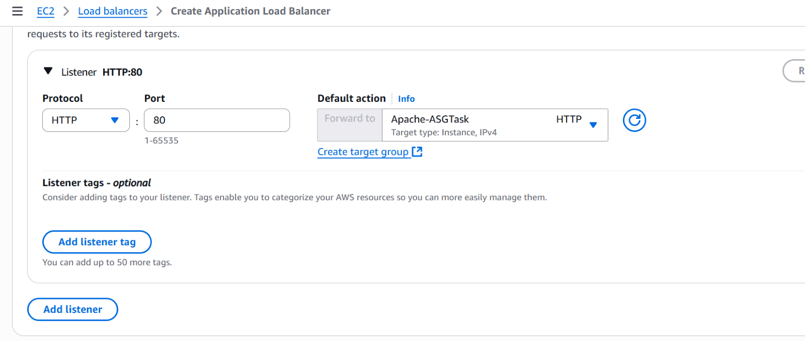

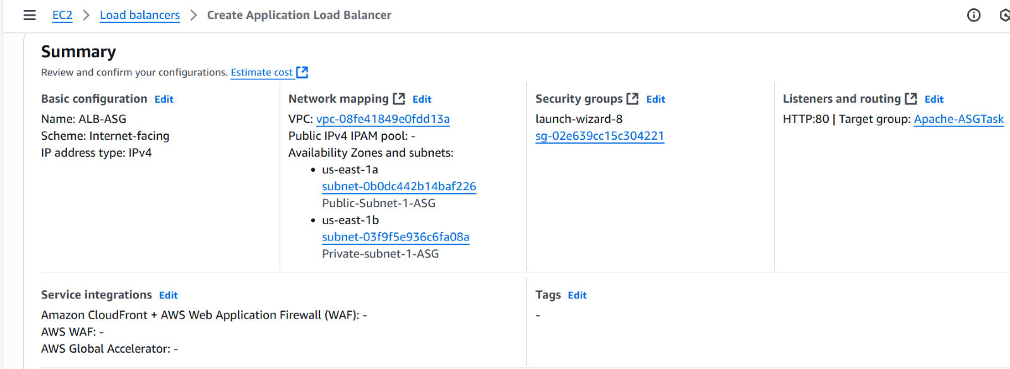

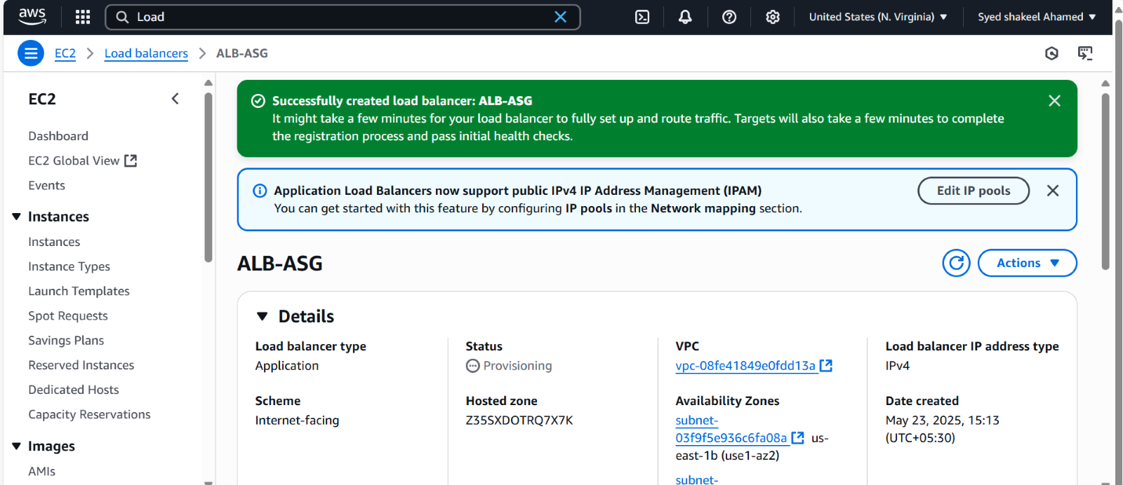

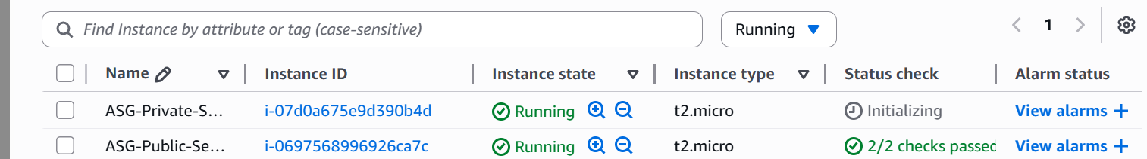

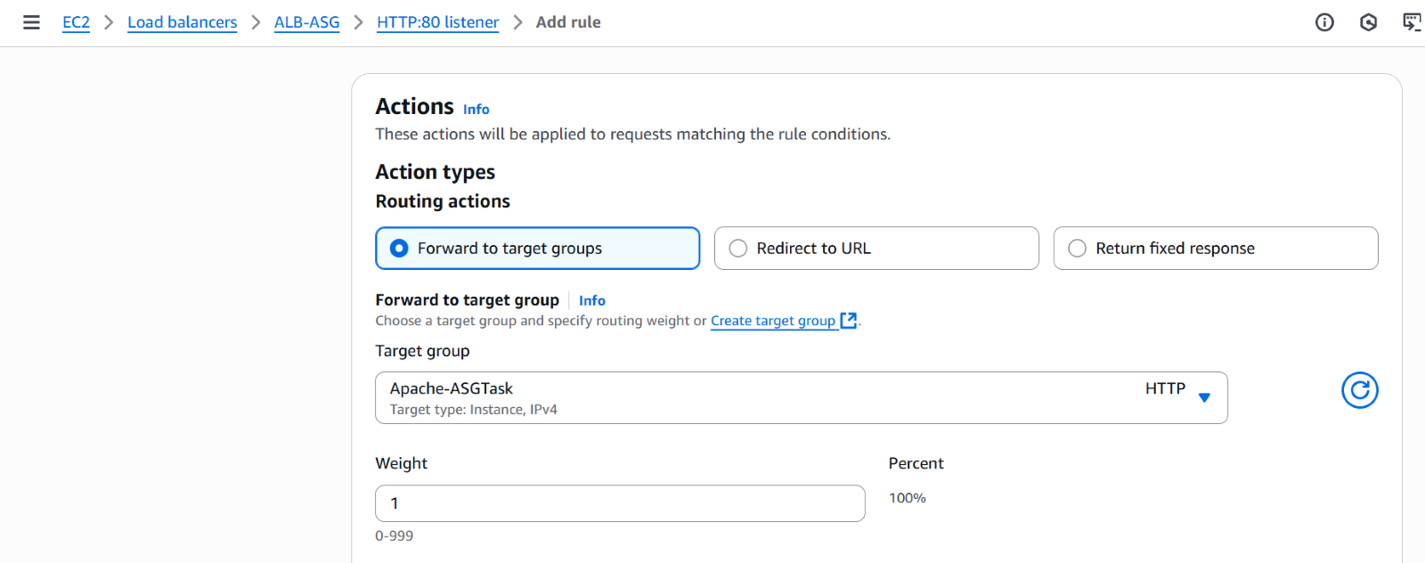

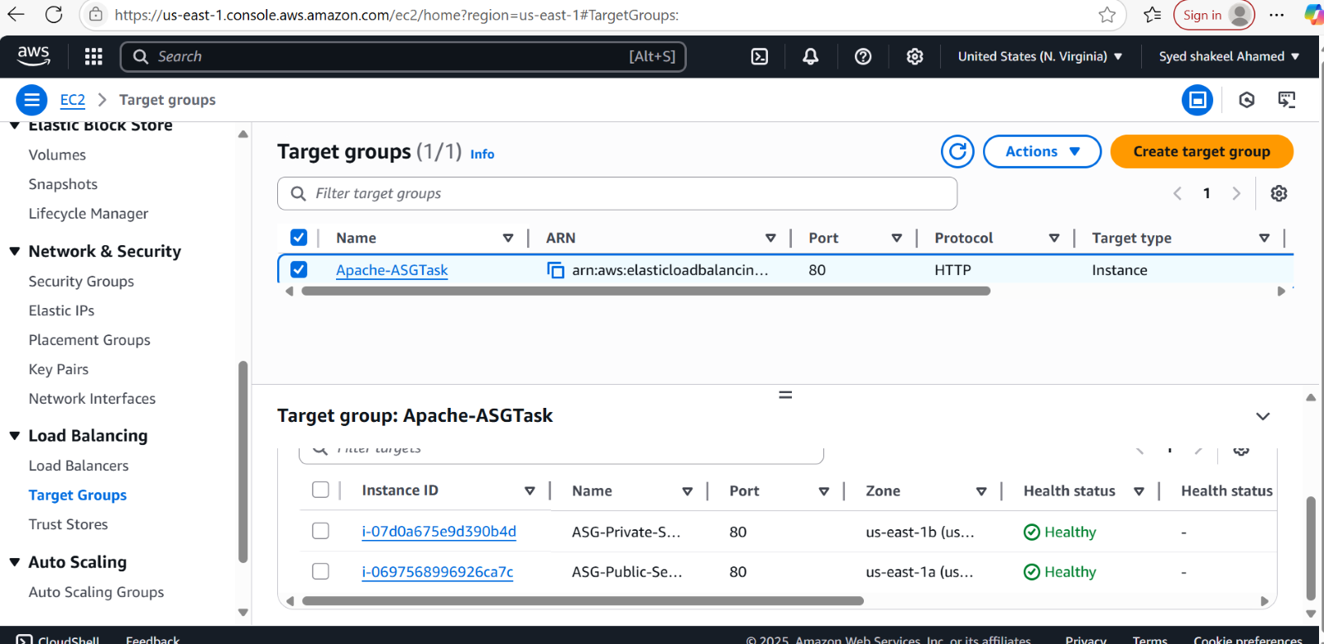

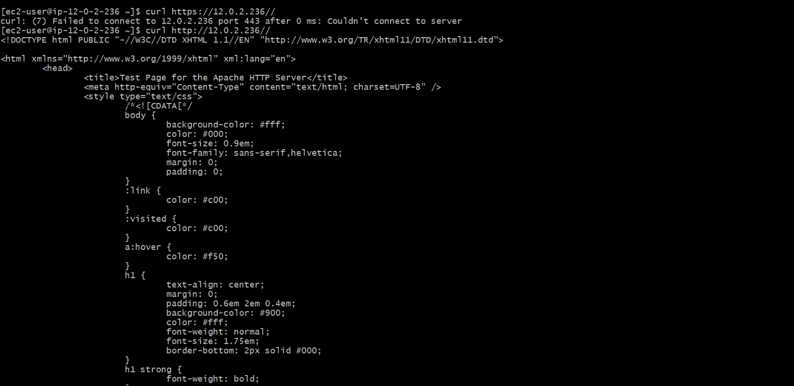

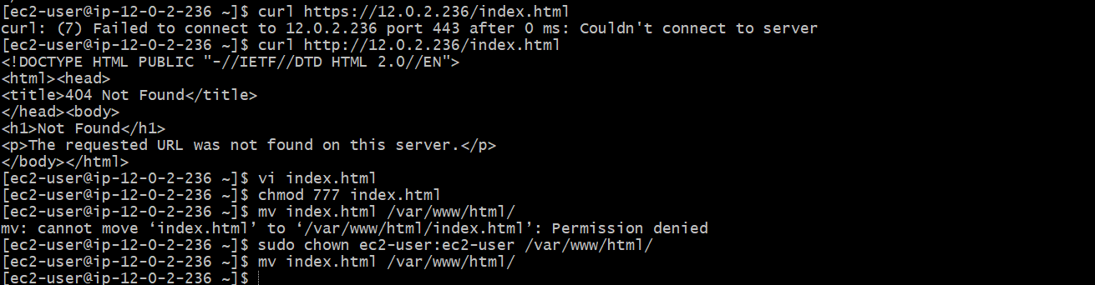

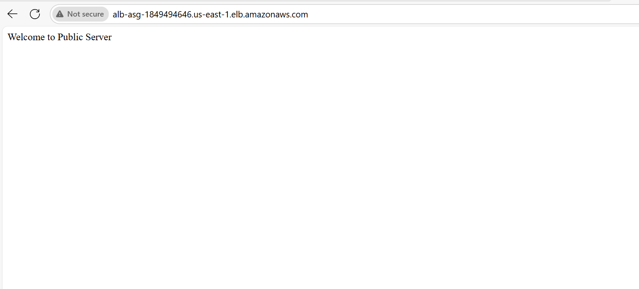

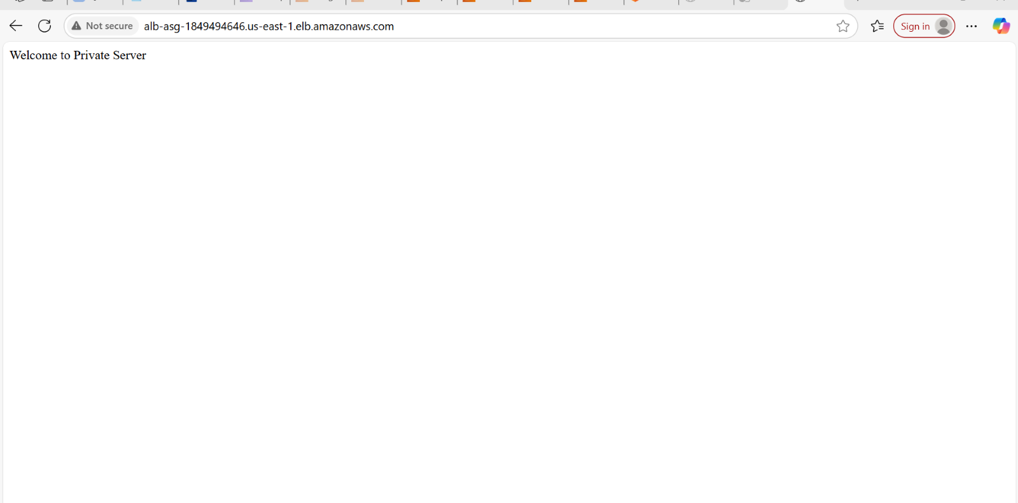

3) Configure Network Load balancer

**Create a Target Group**

1. Open the **AWS EC2 console**.
2. Navigate to **Load Balancing** → **Target Groups**.
3. Click **Create target group**.
4. Choose **Target type** (Instances, IP addresses, or Lambda function).
5. Select **Protocol** (TCP, TLS, or UDP) and **Port** (e.g., 80 or 443).
6. Choose the **VPC** where your instances are deployed.
7. Configure **Health checks** (Protocol, Path, Interval, Thresholds).
8. Click **Create target group**.

**Create a Network Load Balancer**

1. Go to **EC2** → **Load Balancers**.
2. Click **Create Load Balancer** → Select **Network Load Balancer**.
3. Enter a **name** for the load balancer.
4. Choose **Internet-facing** or **Internal** based on your needs.
5. Select **VPC** and **Availability Zones**.
6. Assign **Elastic IPs** (optional) for static IP addresses.

**Configure Listeners**

1. Click **Add listener**.
2. Choose **Protocol** (TCP, TLS, or UDP) and **Port** (e.g., 80 or 443).
3. Select the **Target Group** created earlier.
4. Click **Create Load Balancer**.

**Register Targets**

1. Go to **Target Groups**.
2. Select the target group.
3. Click **Register targets**.
4. Choose **EC2 instances** or **IP addresses**.
5. Click **Include as pending** → **Register targets**.

**Verify and Test using NLB DNS in the browser**

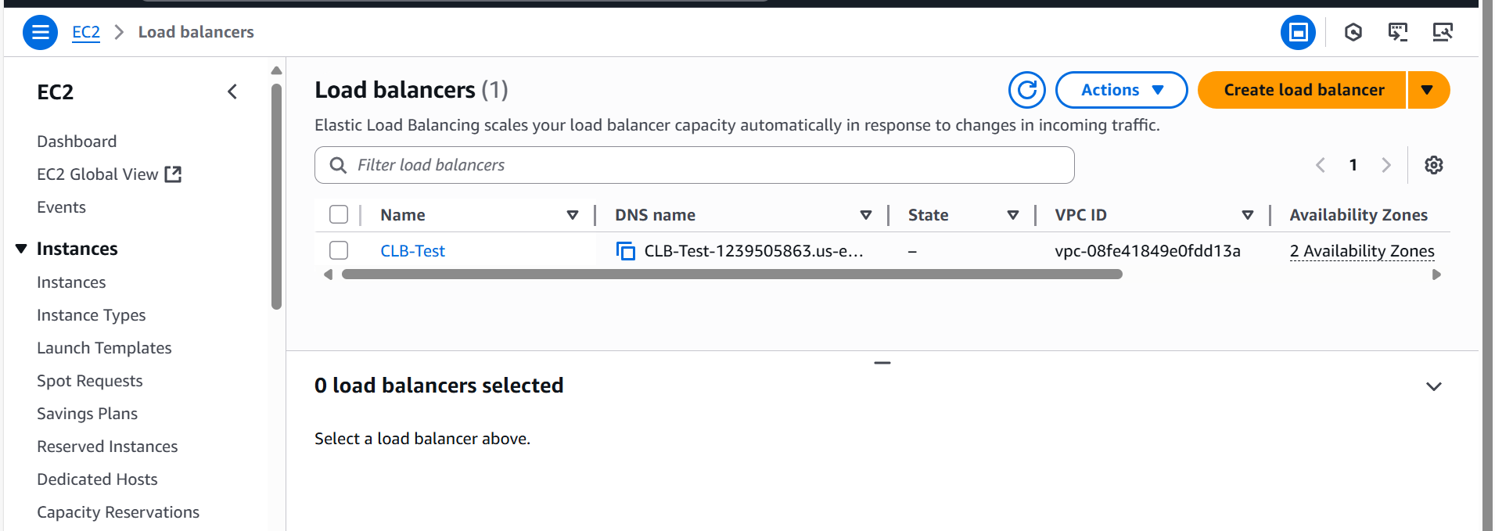

**How Network Load Balancers work**

1. Clients make requests to your application.
2. The load balancer receives the request either directly or through an endpoint for private connectivity (via AWS PrivateLink).
3. The listeners in your load balancer receive requests of matching protocol and port, and route these requests based on the default action that you specify. You can use a TLS listener to offload the work of encryption and decryption to your load balancer.
4. Healthy targets in one or more target groups receive traffic according to the flow hash algorithm.

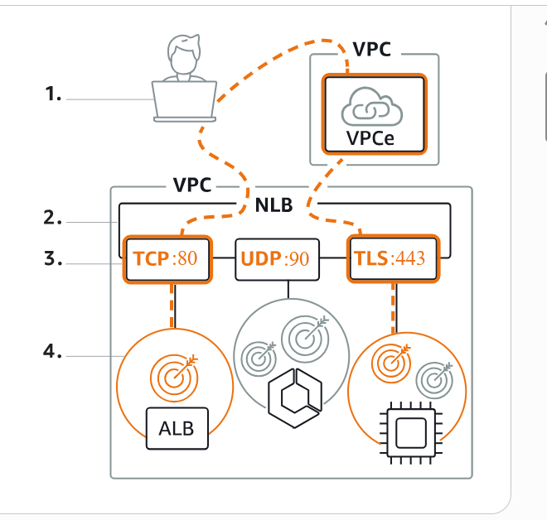

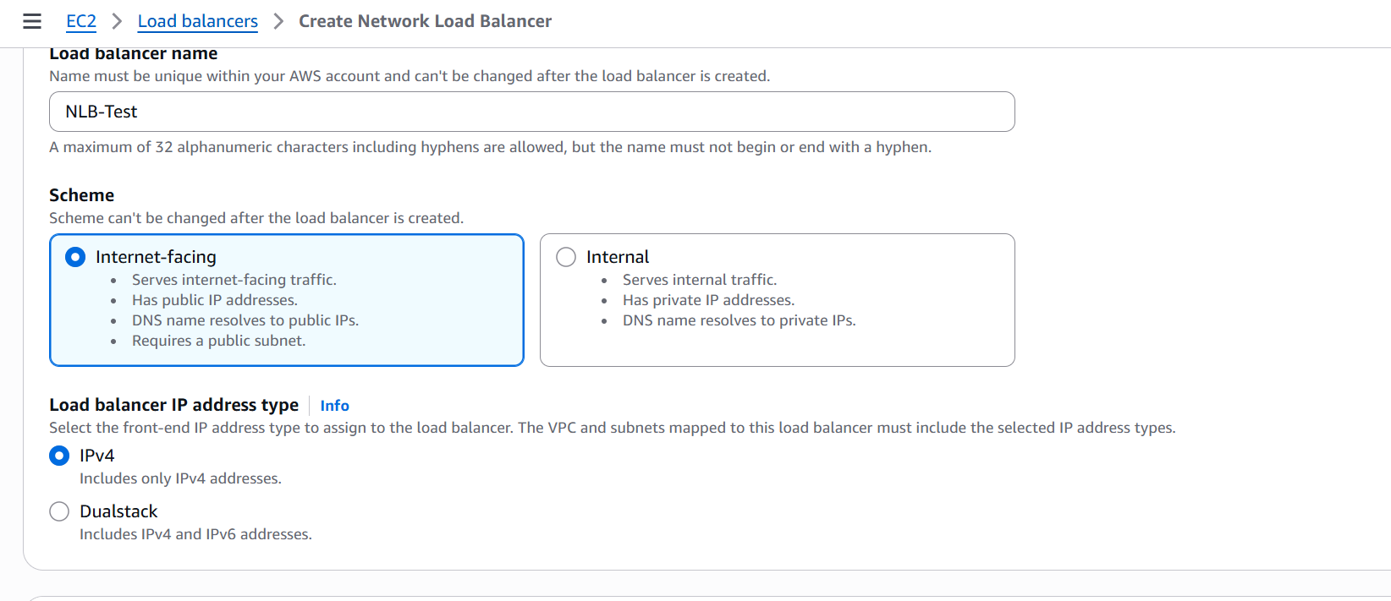

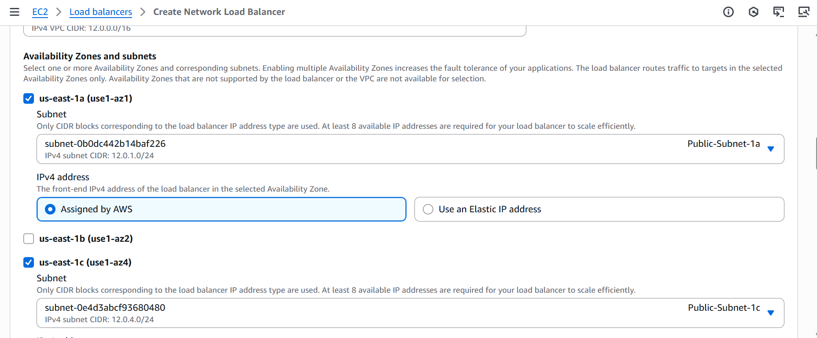

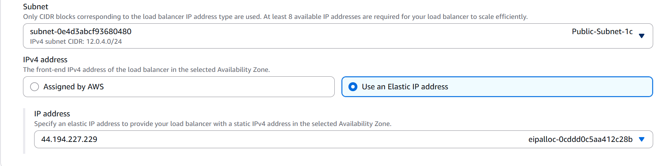

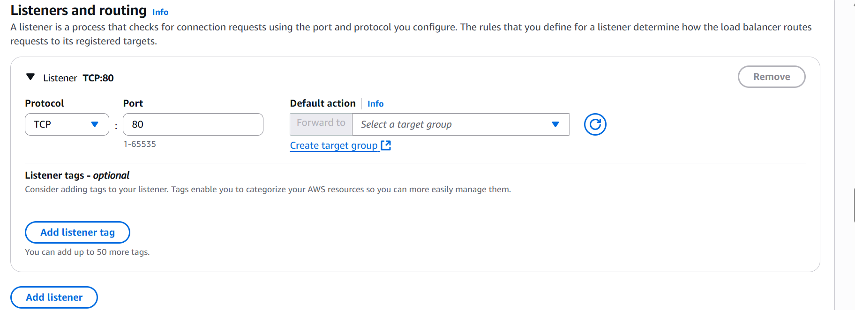

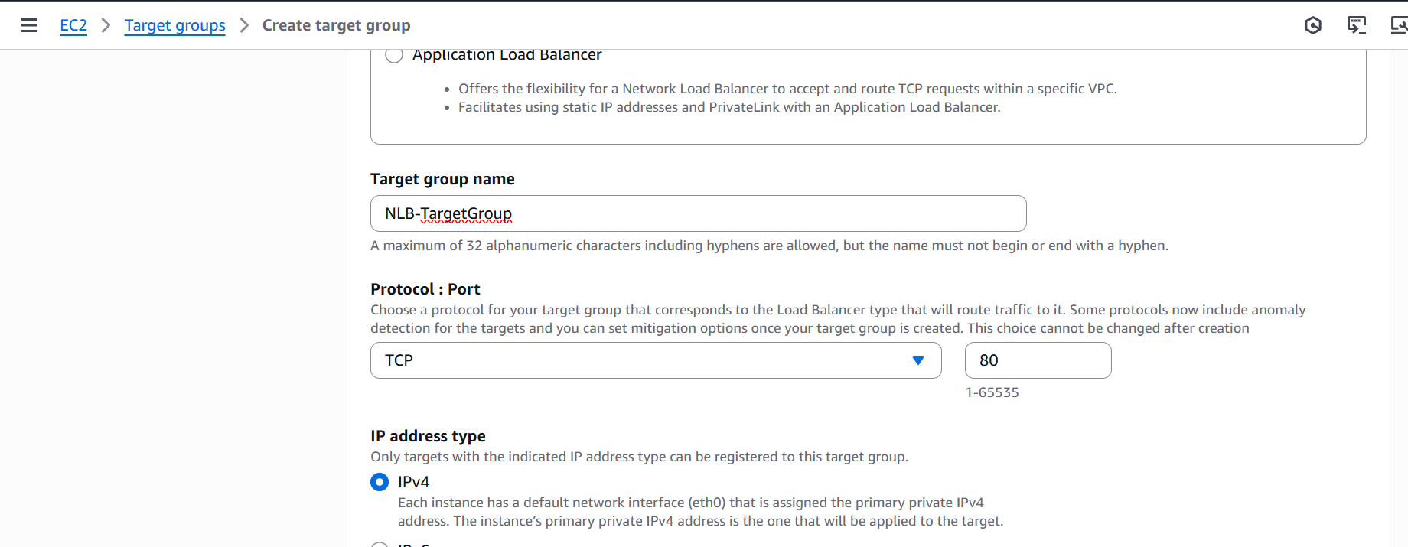

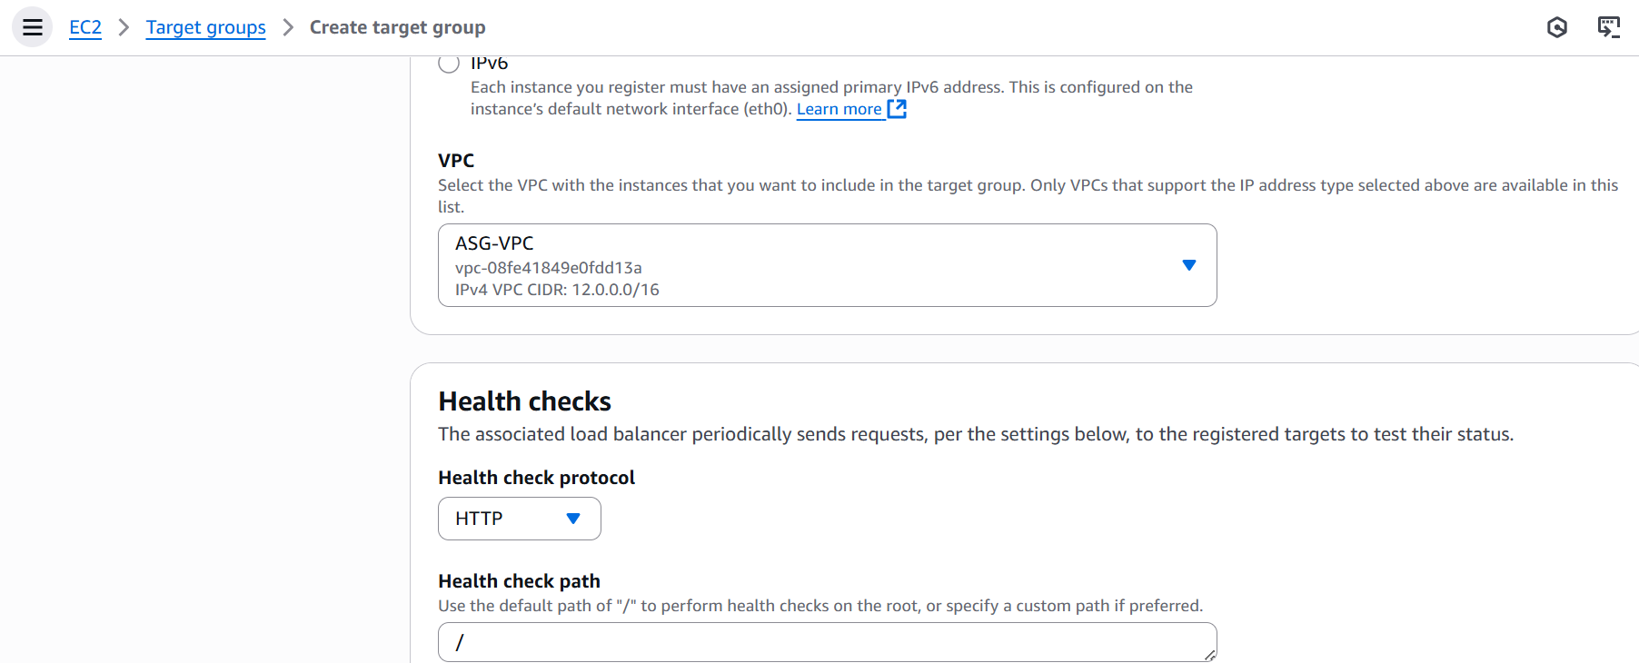

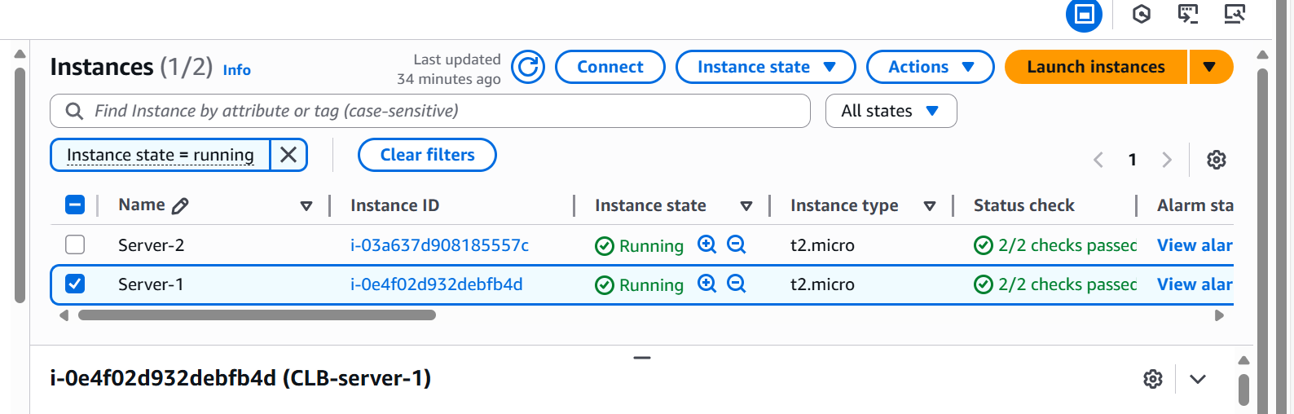

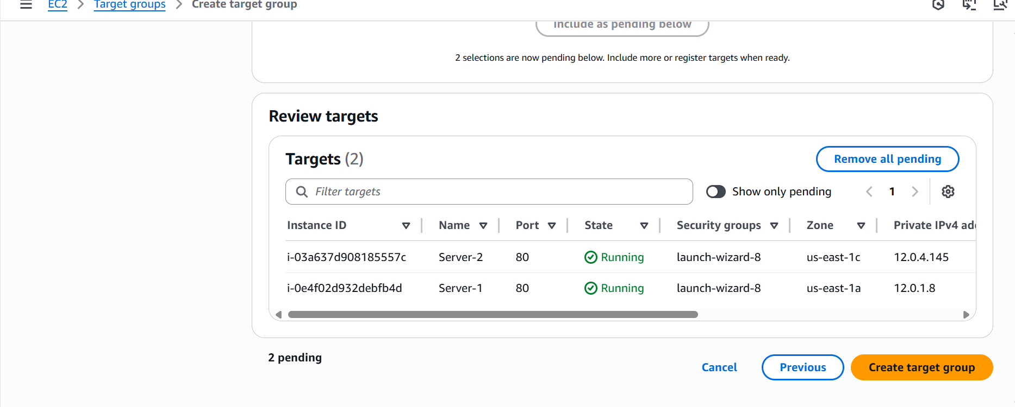

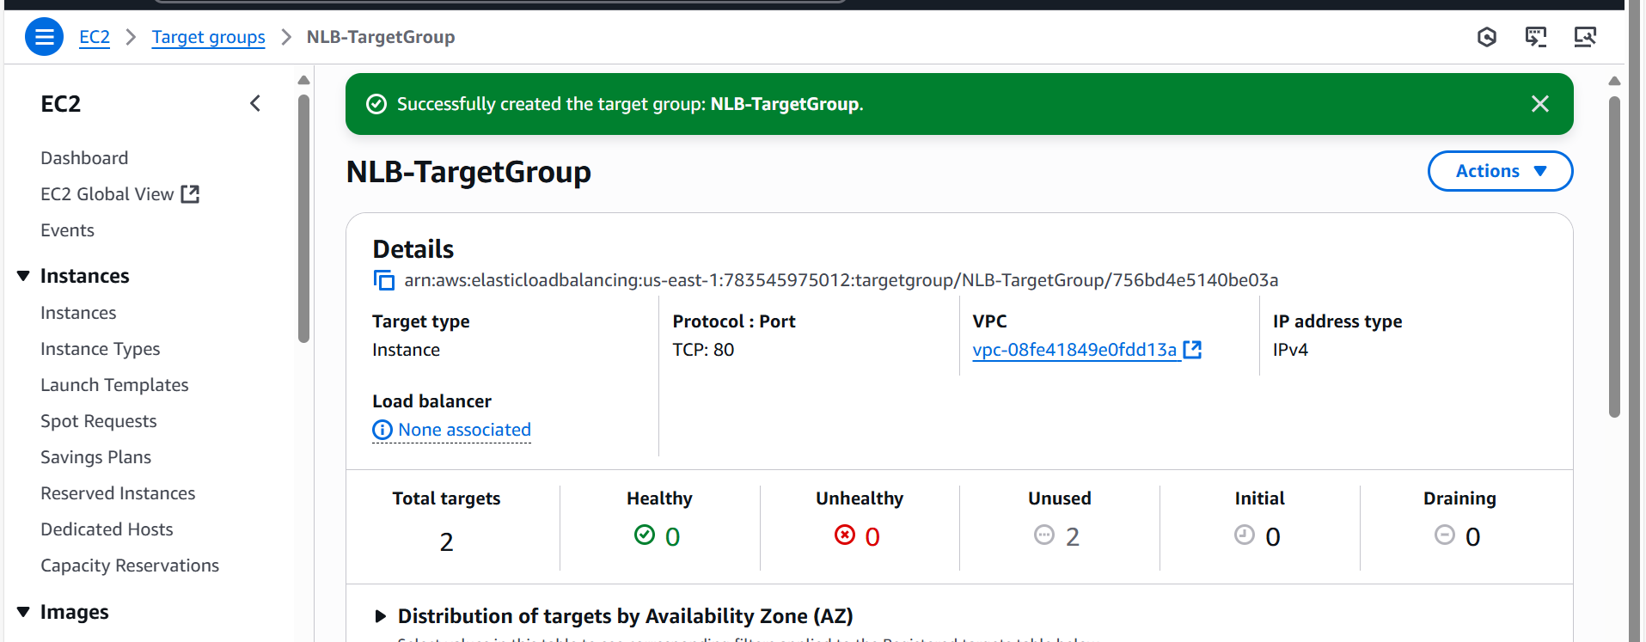

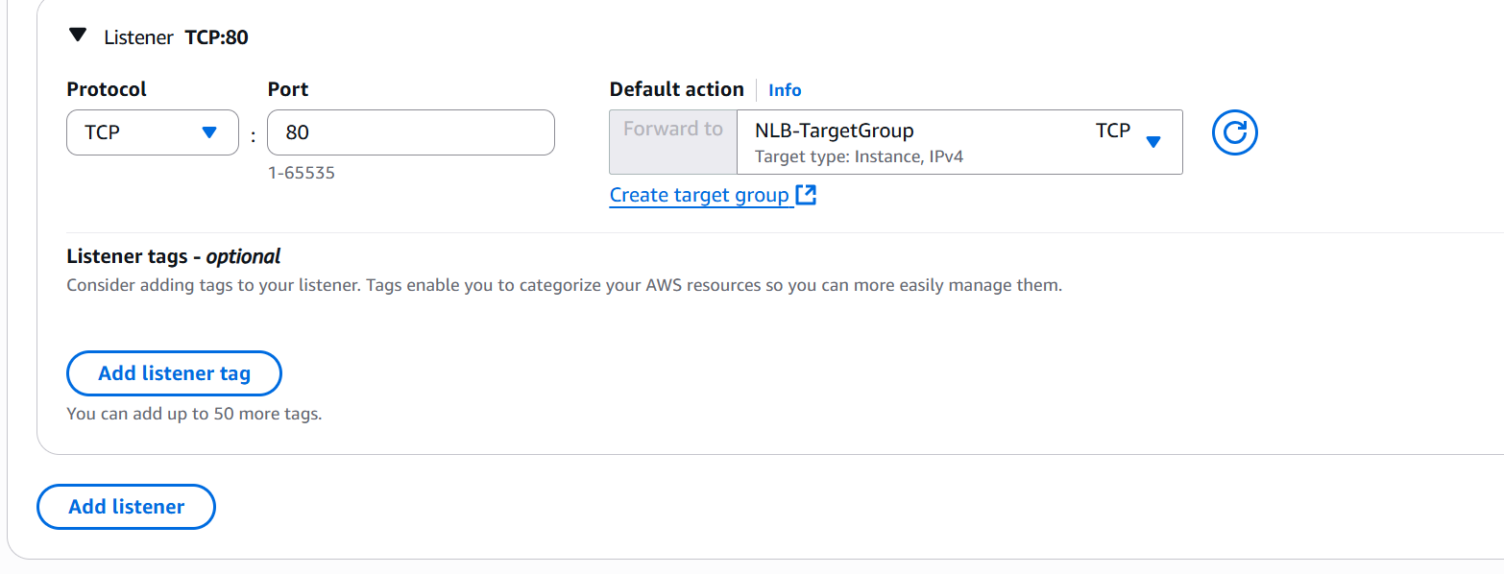

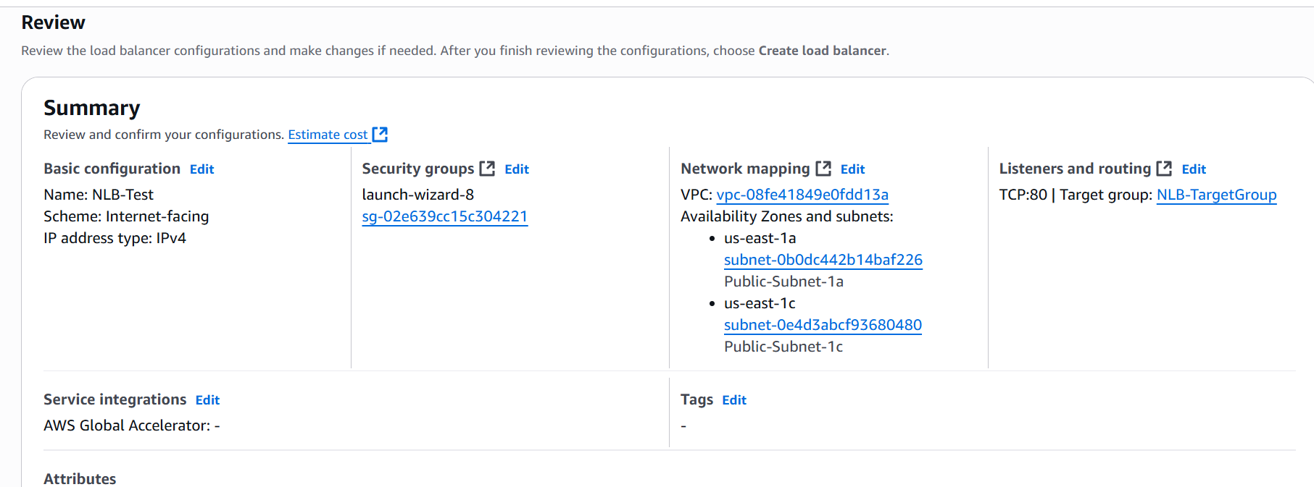

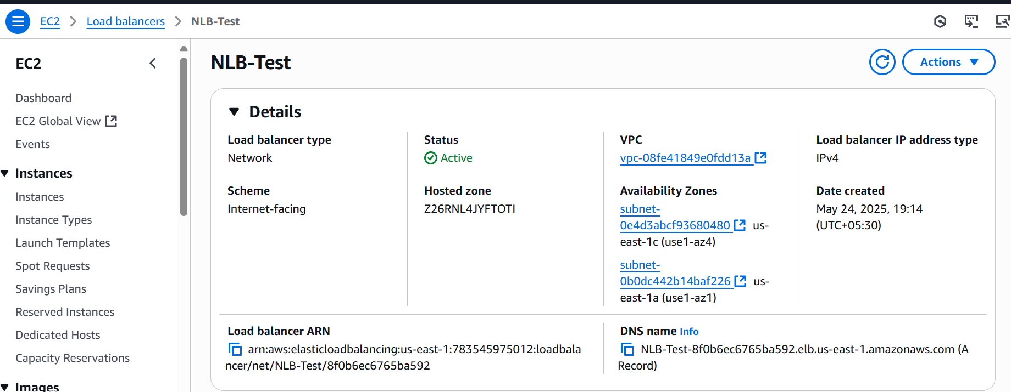

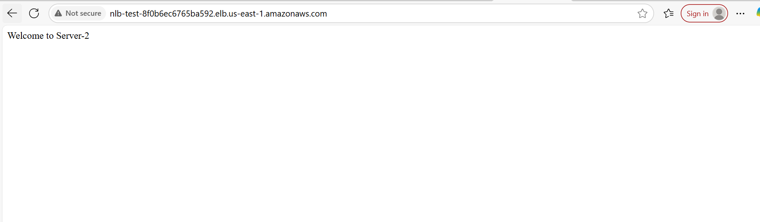

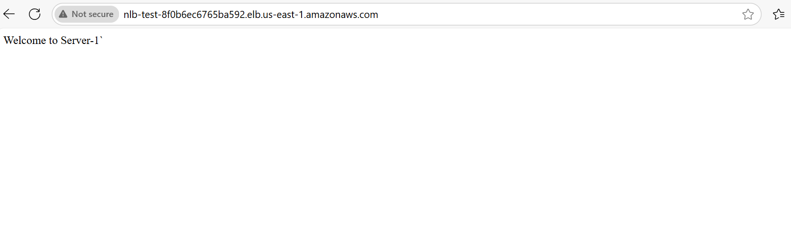

4) Attach SSL for application load balancer

**Obtain an SSL Certificate**

* Use **AWS Certificate Manager (ACM)** to request a public SSL certificate.
* Navigate to **ACM** in the AWS console.
* Click **Request a certificate** → Select **Public certificate**.
* Enter your domain name (syedawsdevops.shop).
* Choose **DNS validation** (recommended) or **Email validation**.
* Complete the validation process.

**Create an HTTPS Listener for ALB**

* Go to **EC2** → **Load Balancers**.
* Select your **Application Load Balancer**.
* Click **Listeners** → **Add listener**.
* Choose **HTTPS (Port 443)**.
* Select the **SSL certificate** from ACM.
* Choose a **security policy** (e.g., ELBSecurityPolicy-TLS-1-2-2017-01).
* Click **Save**.

**Update Security Groups**

* Ensure the **ALB security group** allows inbound traffic on **port 443**.
* Ensure the **target instances** allow traffic from the ALB.

**Modify Target Group Health Checks**

* Go to **Target Groups**.
* Select your target group.
* Click **Health checks** → Update the **protocol** to **HTTPS** if necessary.
* Ensure the health check path returns a **200 OK** response.

5) Map Application load balancer to R53

**Get the ALB DNS Name**

* Go to **EC2** → **Load Balancers**.
* Select your **Application Load Balancer**.
* Copy the **DNS name** of the ALB (e.g., alb-1234567890.us-east-1.elb.amazonaws.com).

**Step 2: Navigate to Route 53**

* Open the **Route 53** console.
* Click **Hosted Zones**.
* Select the hosted zone for your domain (e.g., example.com).

**Step 3: Create an Alias Record**

* Click **Create Record**.
* Choose **Record Type** → Select **A (Alias)**.
* Click **Alias to Application and Classic Load Balancer**.
* Select the **Region** where your ALB is deployed.
* Choose your **ALB DNS name** from the dropdown.
* Click **Create Record**.

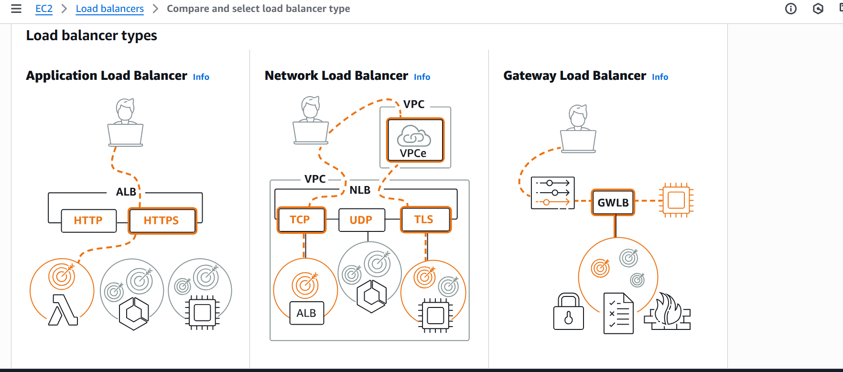

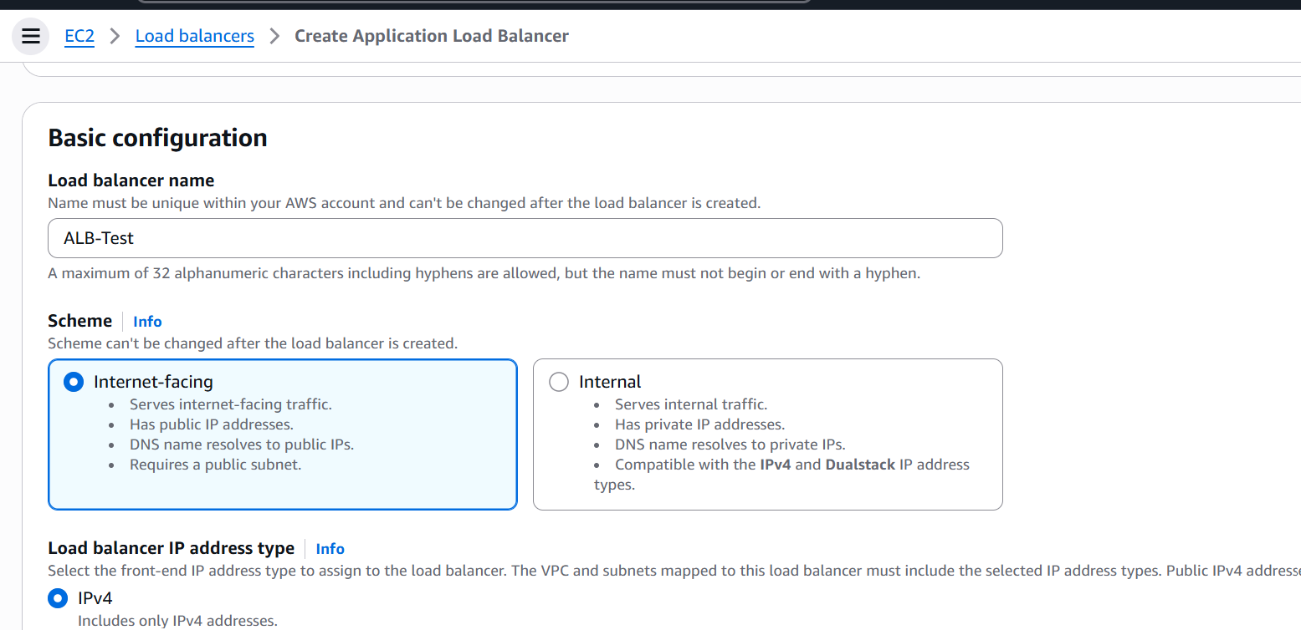

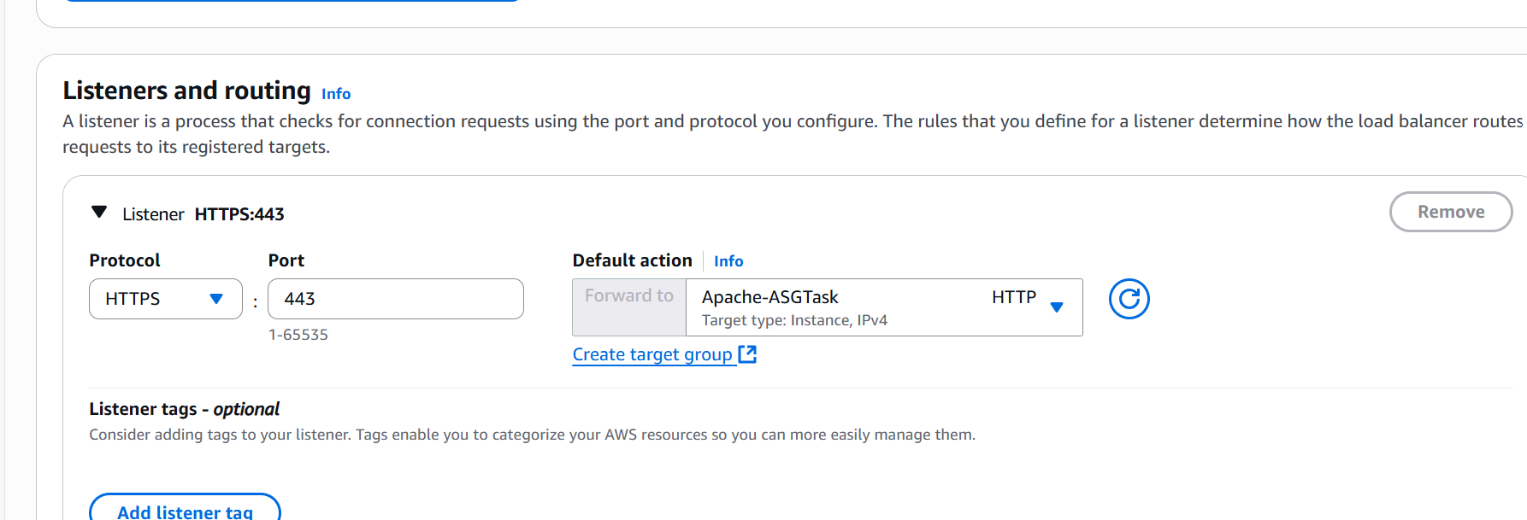

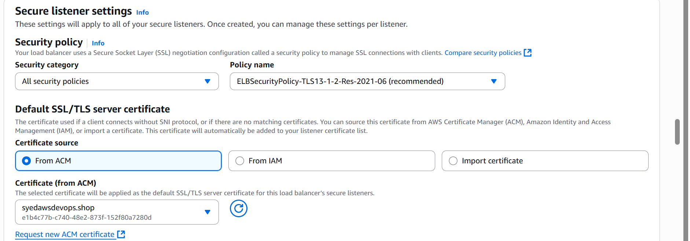

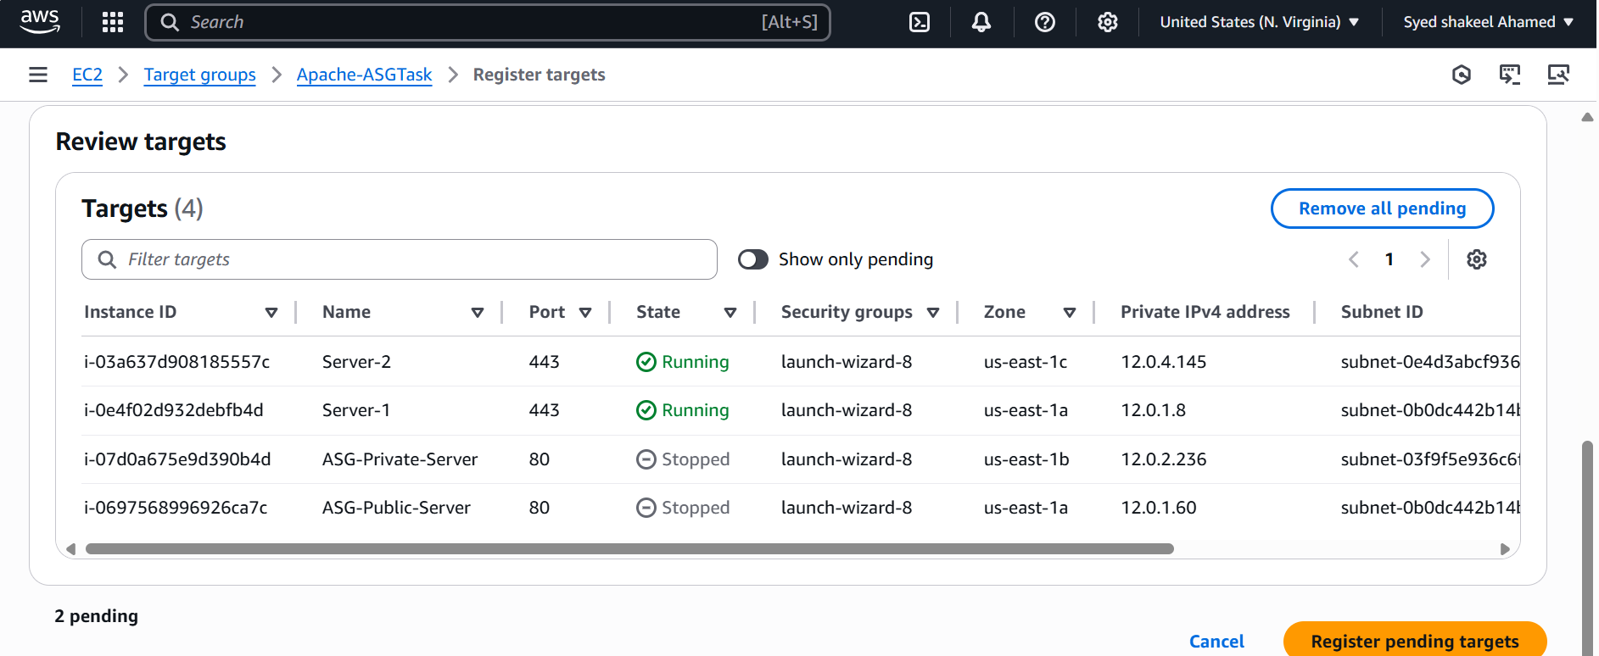

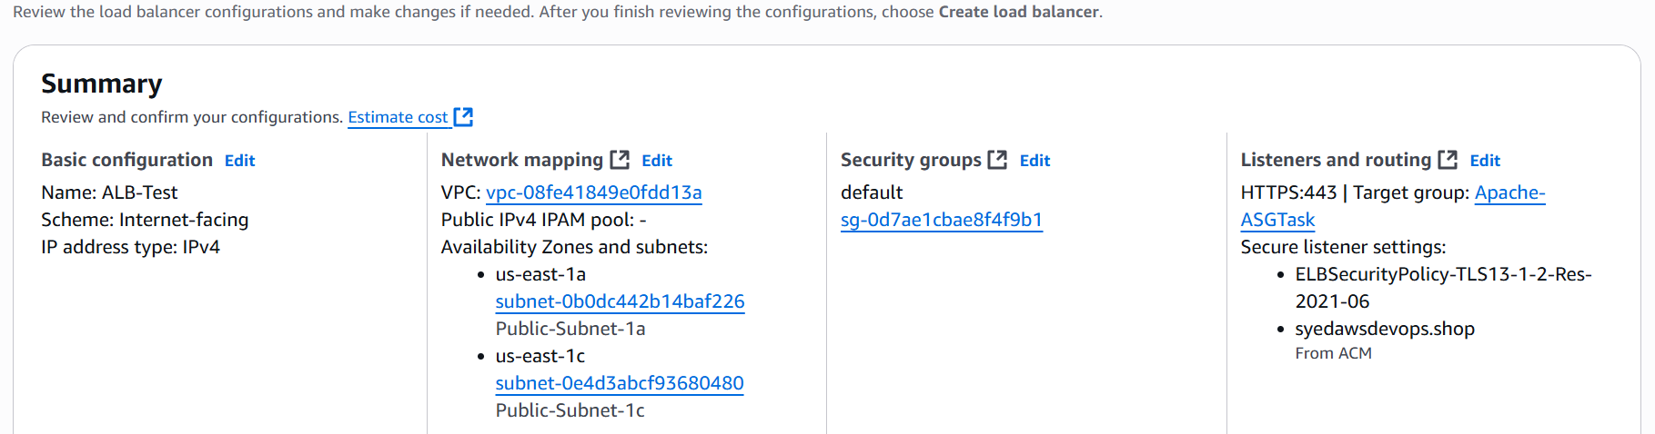

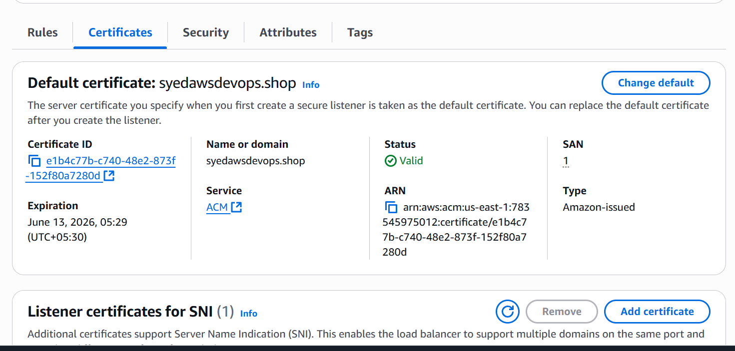

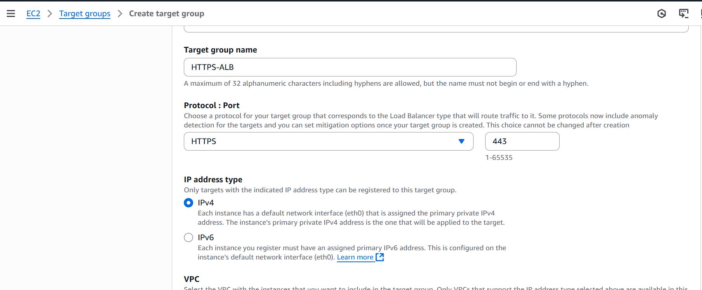

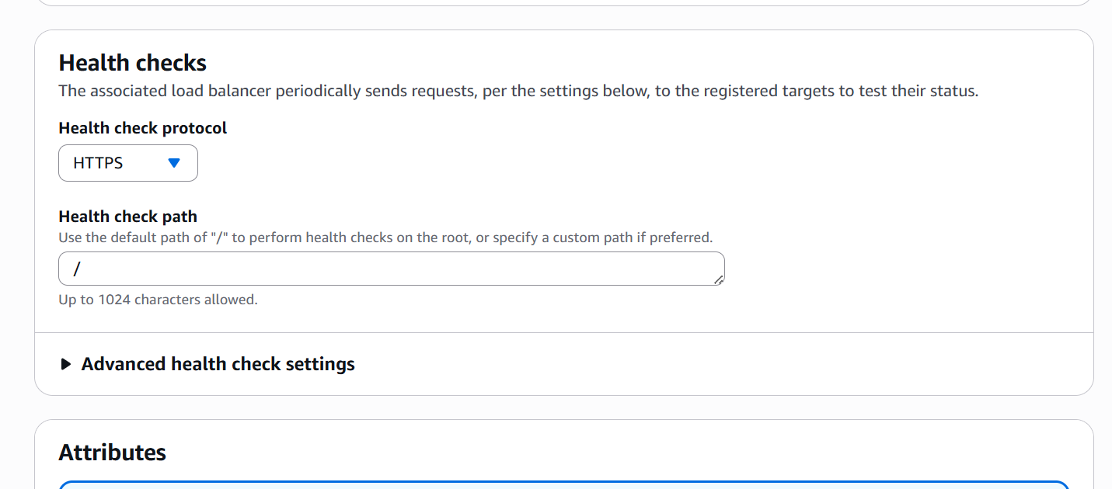

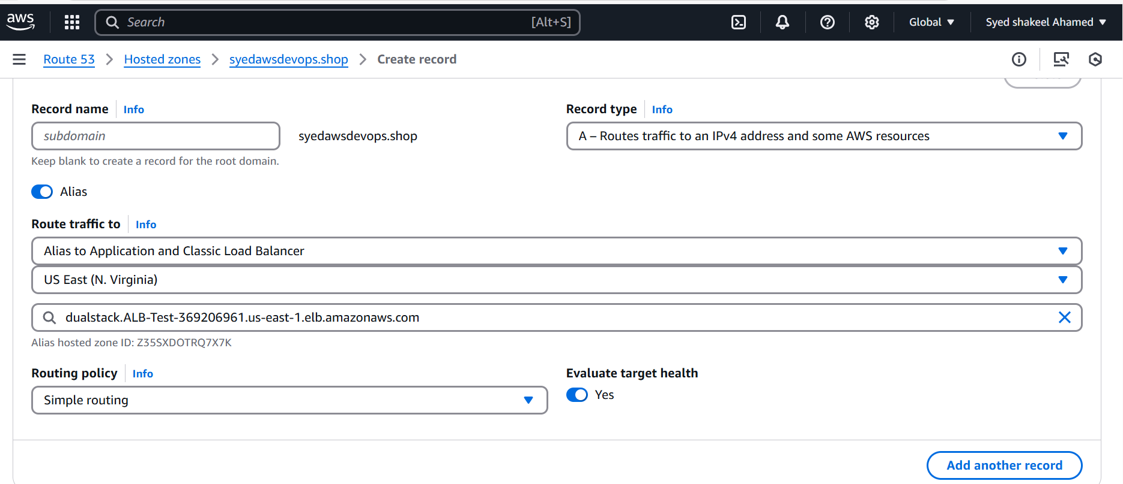

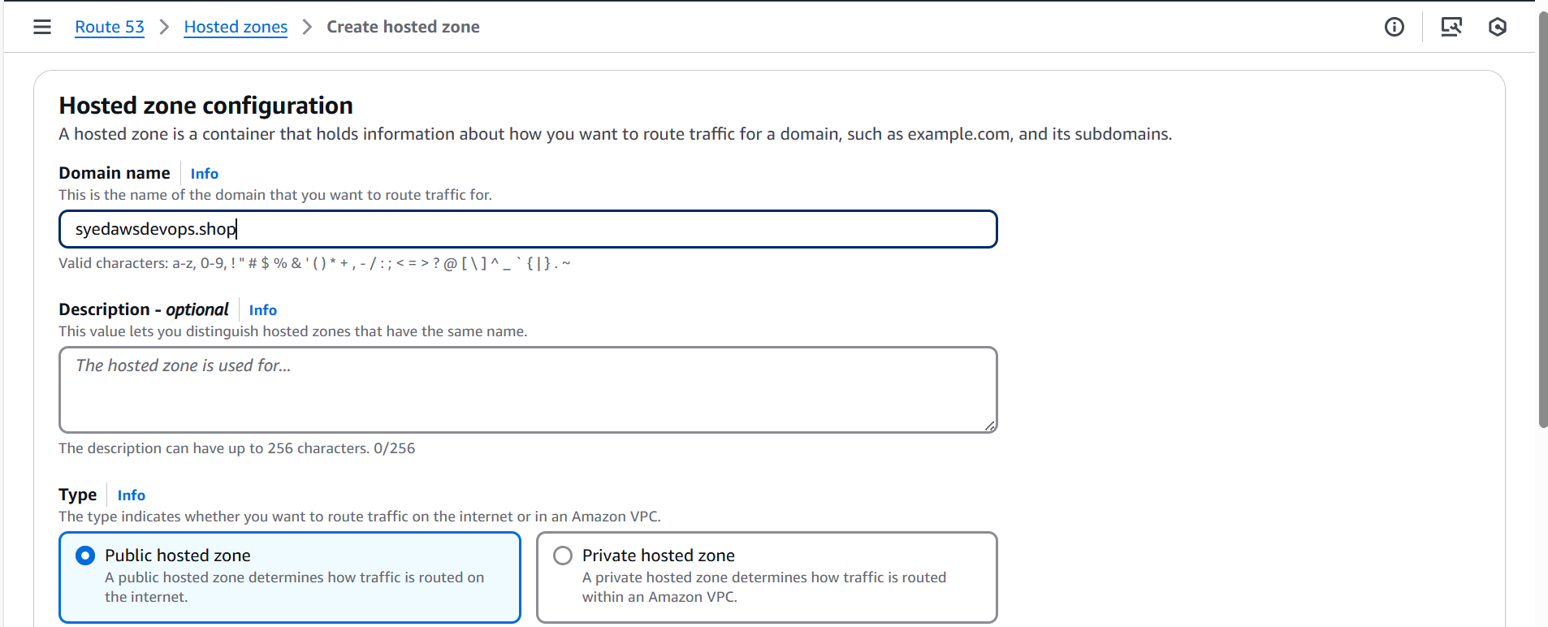

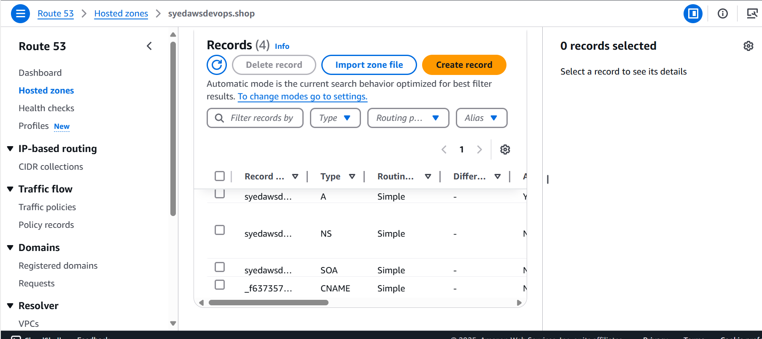

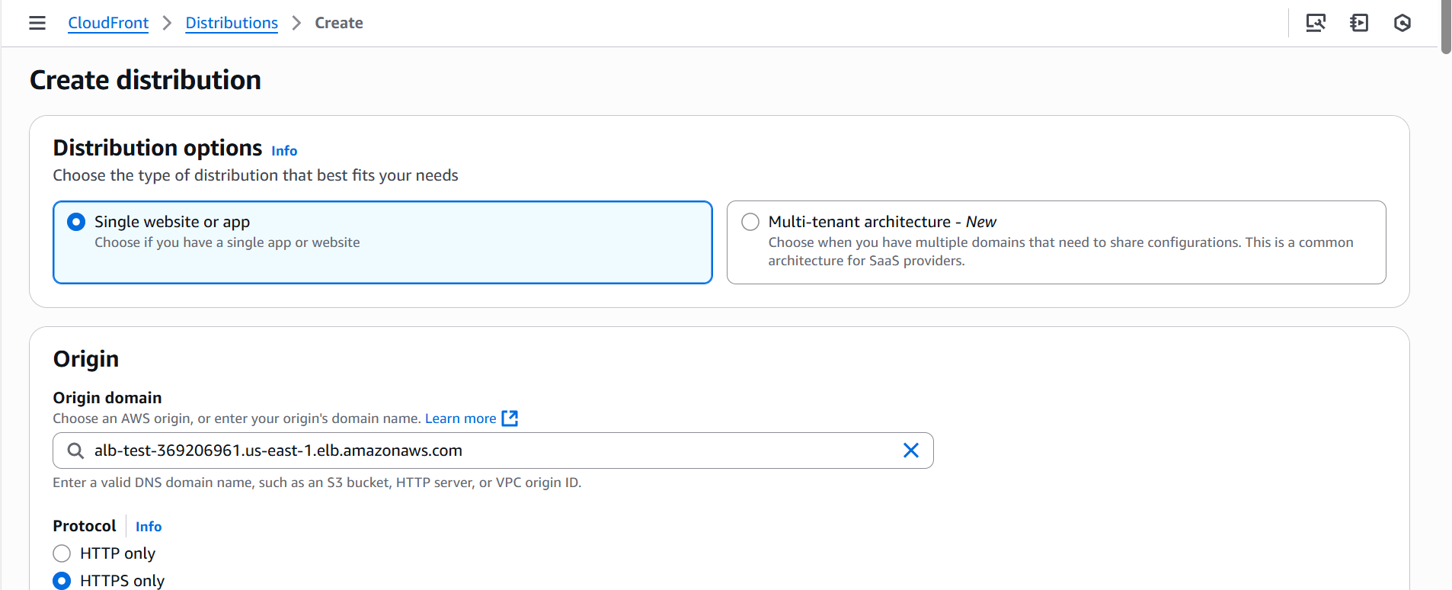

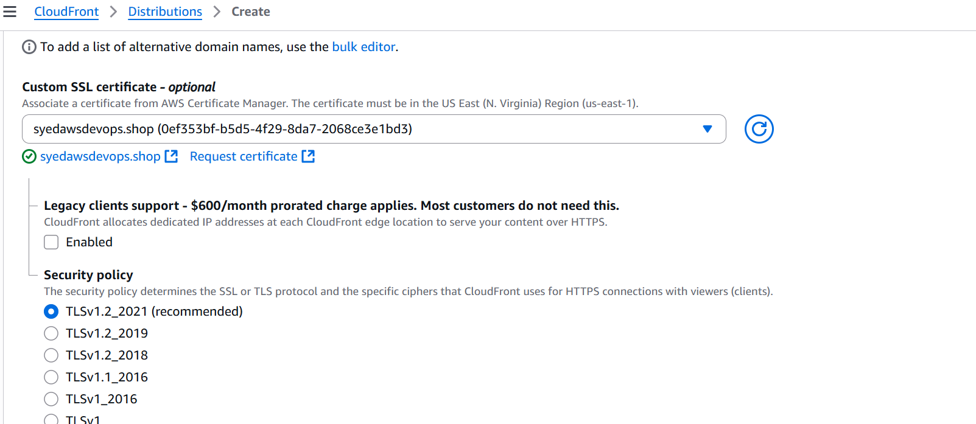

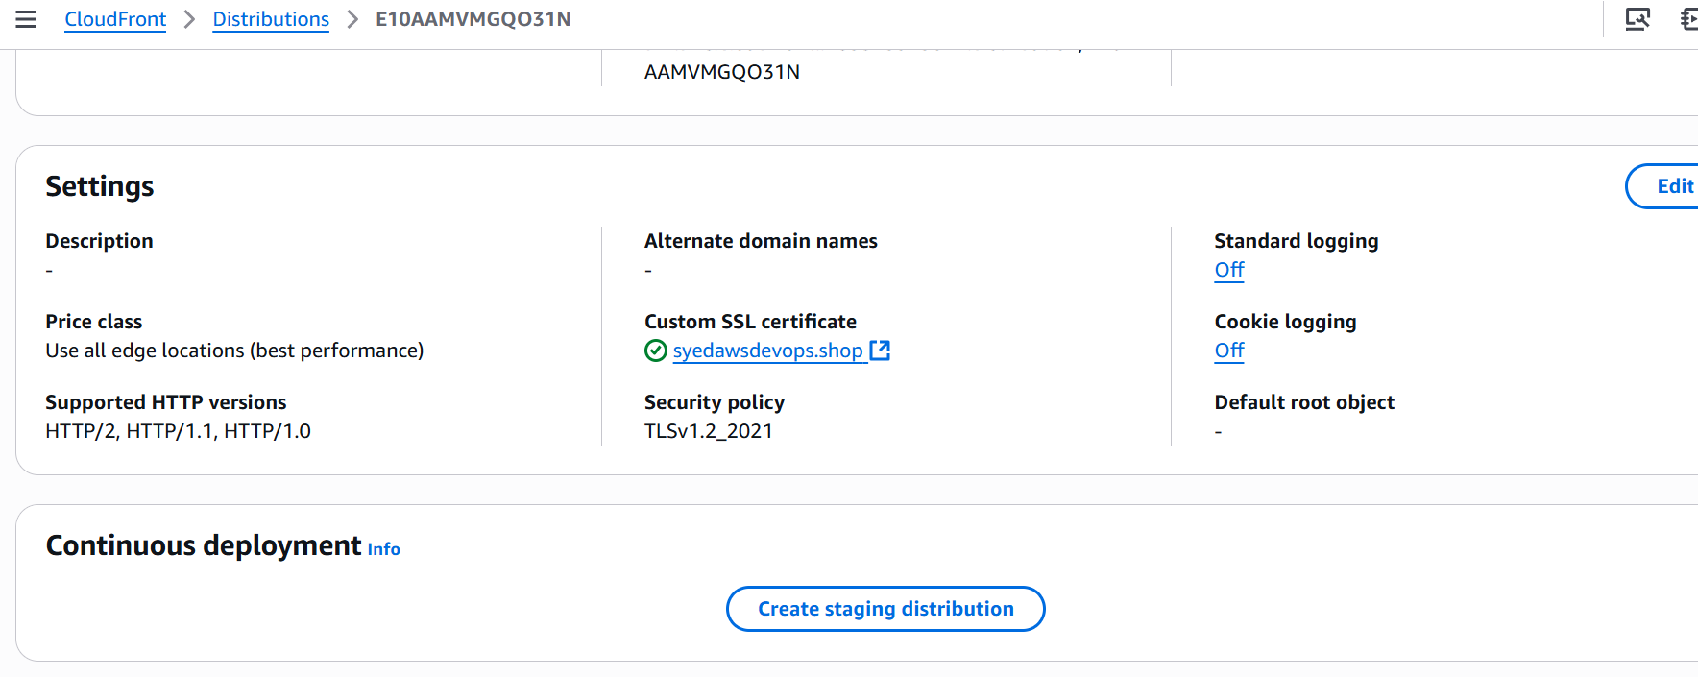

Validation

1.ALB-DNS

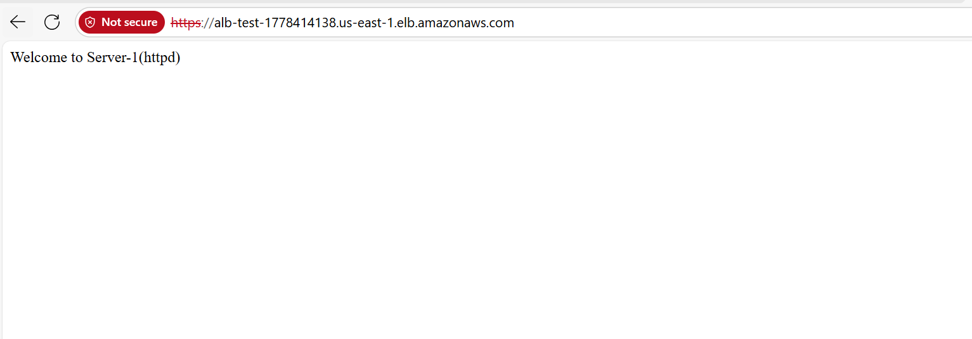

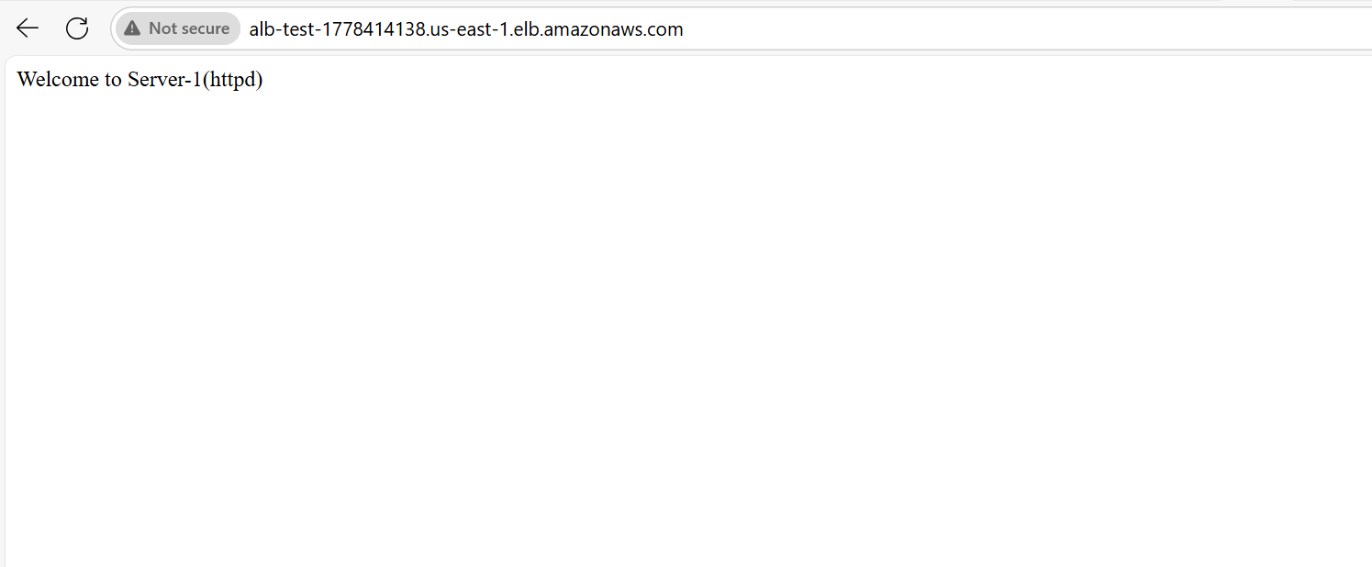

2.Cloudfront-DNS

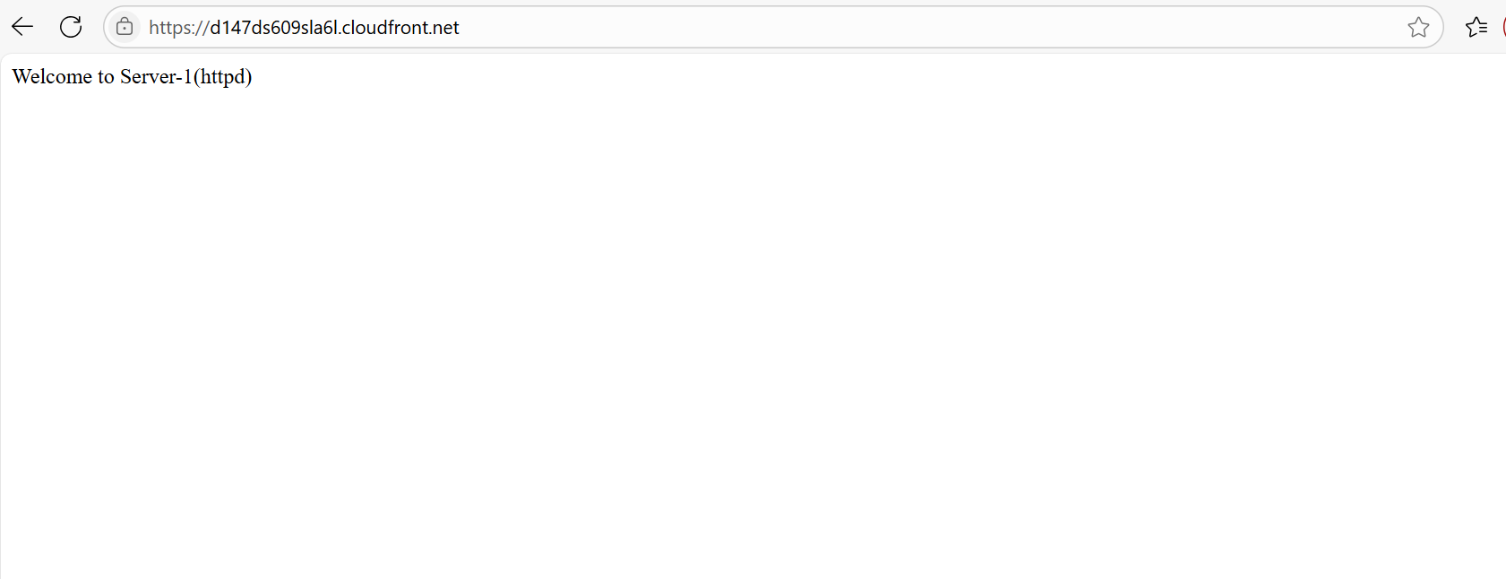

3. Domain

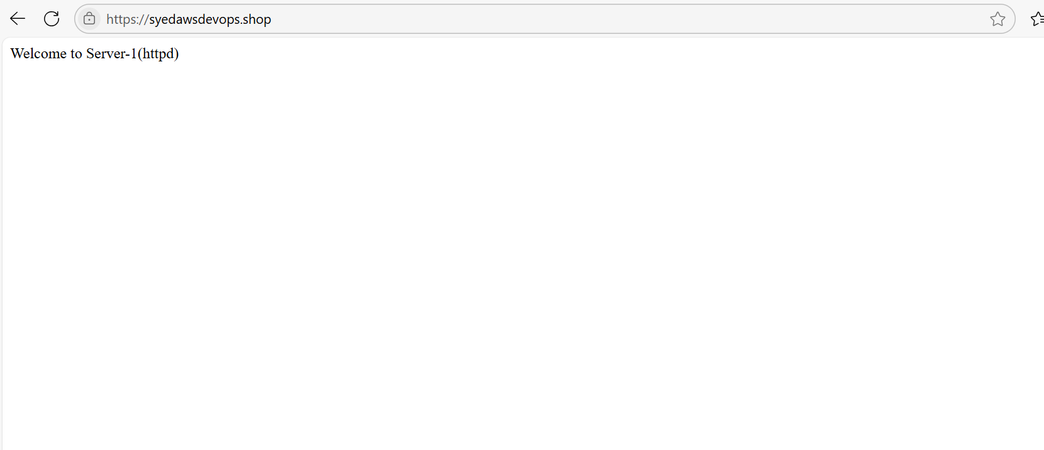

6) Push the application load balancer logs to s3

Go to AWS console and select S3

Go to AWS S3 dashboard

And select the bucket which you have already created

Or you can create the new S3 bucket

**Attach a Bucket Policy for ALB Logging**

* Go to **S3** → Select your bucket.
* Click **Permissions** → **Bucket Policy**.

**Enable ALB Access Logging**

* Go to **EC2** → **Load Balancers**.
* Select your **Application Load Balancer**.
* Click **Attributes** → **Access logs**.
* Click **Edit** → Enable **Access logs**.
* Enter the **S3 bucket name** (alb-logs-bucket).
* Click **Save changes**.

**Verify Log Delivery**

* Wait a few minutes for logs to appear in S3.
* Navigate to **S3** → Open the bucket.
* Check for log files under the prefix AWSLogs/.

